|  |
| --- |
|  |
| TARGET FAT GALICIA |
|  |

|  | Name | Role/Title |
| --- | --- | --- |
| Owner | Anders Sandström | Electronics Engineer Motion Control & Automation |
| Reviewer |  |  |
| Approver |  |  |

TABLE OF CONTENT PAGE

1. Background 5

2. Control and Measurement SYSTEMs 6

2.1. Measurement system 6

2.2. Hardware 6

2.3. EL5021 Encoder interface 7

2.4. EL3174 Analog interface 7

2.1. ILD2300 Position sensor 8

2.2. Control system for rotational drive 9

2.1. Control system for stepper drives 10

3. Test Execution 11

3.1. Monday 11

3.2. Tuesday 12

3.2.1. Assembly 12

3.2.2. Commissioning 12

3.2.3. First rotation 13

3.2.4. Wednesday 14

3.2.5. Thursday 14

4. Analysis: Rotation velocity stability 15

4.1. Method 15

4.2. Velocity ramp-up 16

4.3. Constant velocity 17

4.4. Velocity ramp-down 20

4.5. Summary velocity variations 23

5. Analysis: Rotor Displacement 24

5.1. Velocity ramp-up 24

5.2. Constant Velocity 24

5.3. Velocity ramp-down 26

6. Analysis: Rotation 10h test 28

6.1. Torque, temperature and velocity 28

6.1.1. Rotor displacement over 10h (horizontal pedestal sensors) 30

6.1.2. Rotor circumference displacement over 10h (horizontal optical sensor) 32

6.1.3. Rotor vertical displacement over 10h 33

7. Conclusions 34

8. references 35

9. Appendix A Micro Epsilon ILD2300 Calibration REPORT 36

10. Appendix B: Telemess A30-S01 37

11. Appendix C: Telemess A42 38

list of tables

Table 1: Statistics for horizontal pedestal sensors over a 10h period. 31

Table 2: Statistics for horizontal optical sensor measuring circumference position deviation over a 10h period 32

Table 3: Statistics for vertical pedestal sensor measuring vertical position deviation over a 10h period 33

list of Figures

Figure 1: Target wheel, shaft and drive unit 5

Figure 2: Control hardware 6

Figure 3: Amo rotational sin/cos encoder 7

Figure 4: Telemess eddy current sensor positions 7

Figure 5: ILD2300 triangulation sensor 8

Figure 6: Control box for rotational motor (Rexroth) 9

Figure 7: Control box for stepper motors 10

Figure 8: CS-Studio HMI 10

Figure 9: Drive-unit mounting 11

Figure 10: Notch wheel and encoders 12

Figure 11: Target wheel position relative frame at standstill 13

Figure 12: Ramp up 6 to 22 rpm (lower = position, center=velocity, upper=velocity-minus linear component) 16

Figure 13: Ramp up 22 to 28 rpm (lower = position, center=velocity, upper=velocity-minus linear component) 16

Figure 14: Velocity variation Wednesday morning at 24rpm (lower=position, center=velocity, upper=velocity-minus linear component) 17

Figure 15: Velocity variation Wednesday morning at 24rpm for each revolution (lower=velocity vs time, upper=velocity vs angle) 17

Figure 16: Velocity variation Wednesday evening at 24rpm (lower=position, center=velocity, upper=velocity-minus linear component) 18

Figure 17: Velocity variation Wednesday evening at 24rpm for each revolution (lower=velocity vs time, upper=velocity vs angle) 18

Figure 18: Velocity variation Wednesday morning at 28rpm (lower=position, center=velocity, upper=velocity-minus linear component) 19

Figure 19: Velocity variation Wednesday morning at 28rpm for each revolution (lower=velocity vs time, upper=velocity vs angle) 19

Figure 20: Ramp down from 23 rpm (lower = position, center=velocity, upper=velocity-minus linear component). 20

Figure 21: Velocity for each rev vs rotation angle and time (linear velocity component removed) 21

Figure 22: Ramp down from 28 rpm (lower = position, center=velocity, upper=velocity-minus linear component). 22

Figure 23: Velocity for each rev vs rotation angle and time (linear velocity component removed) 22

Figure 24: Rotor positions measured with the 5 position sensors 25

Figure 25: Upper: Manual recorded rotation drive torque [7]. Lower: Temperatures for motor and bearings. 28

Figure 26: Data from drive control software showing torque and velocity for two rotations (approx. 5seconds) 28

Figure 27: Upper: Manual recorded rotation drive torque [7]. Lower: max and min rotational velocities for 10s periods 29

Figure 28: Position measurements for horizontal sensors at 0º, 120º and 240º degrees over a 10h period. Upper graph shows maximum position values and lower graph shows minimum position values. Each value is a maximum or minimum of a 10 second period. 30

Figure 29: Position measurements for the optical sensor measuring circumference deviation over a 10h period. Upper graph shows maximum position values and lower graph shows minimum position values. Each value is a maximum or minimum of a 10 second period. 32

Figure 30: Position measurements for the vertical pedestal sensor over a 10h period. Upper graph shows maximum position values and lower graph shows minimum position values. Each value is a maximum or minimum of a 10 second period. 33

# Background

The target wheel and drive unit FAT took place week 7, 2022 at Thune Eureka premises in Galicia, Spain. This report contains analysis of some data acquired during the FAT tests. Another report covering the FAT will be written by ESS Bilbao and AVS. AVS was responsible for controlling both rotation and the stepper motors during the FAT.

The equipment in scope is the target wheel and shaft assembly as seen in Figure 1.

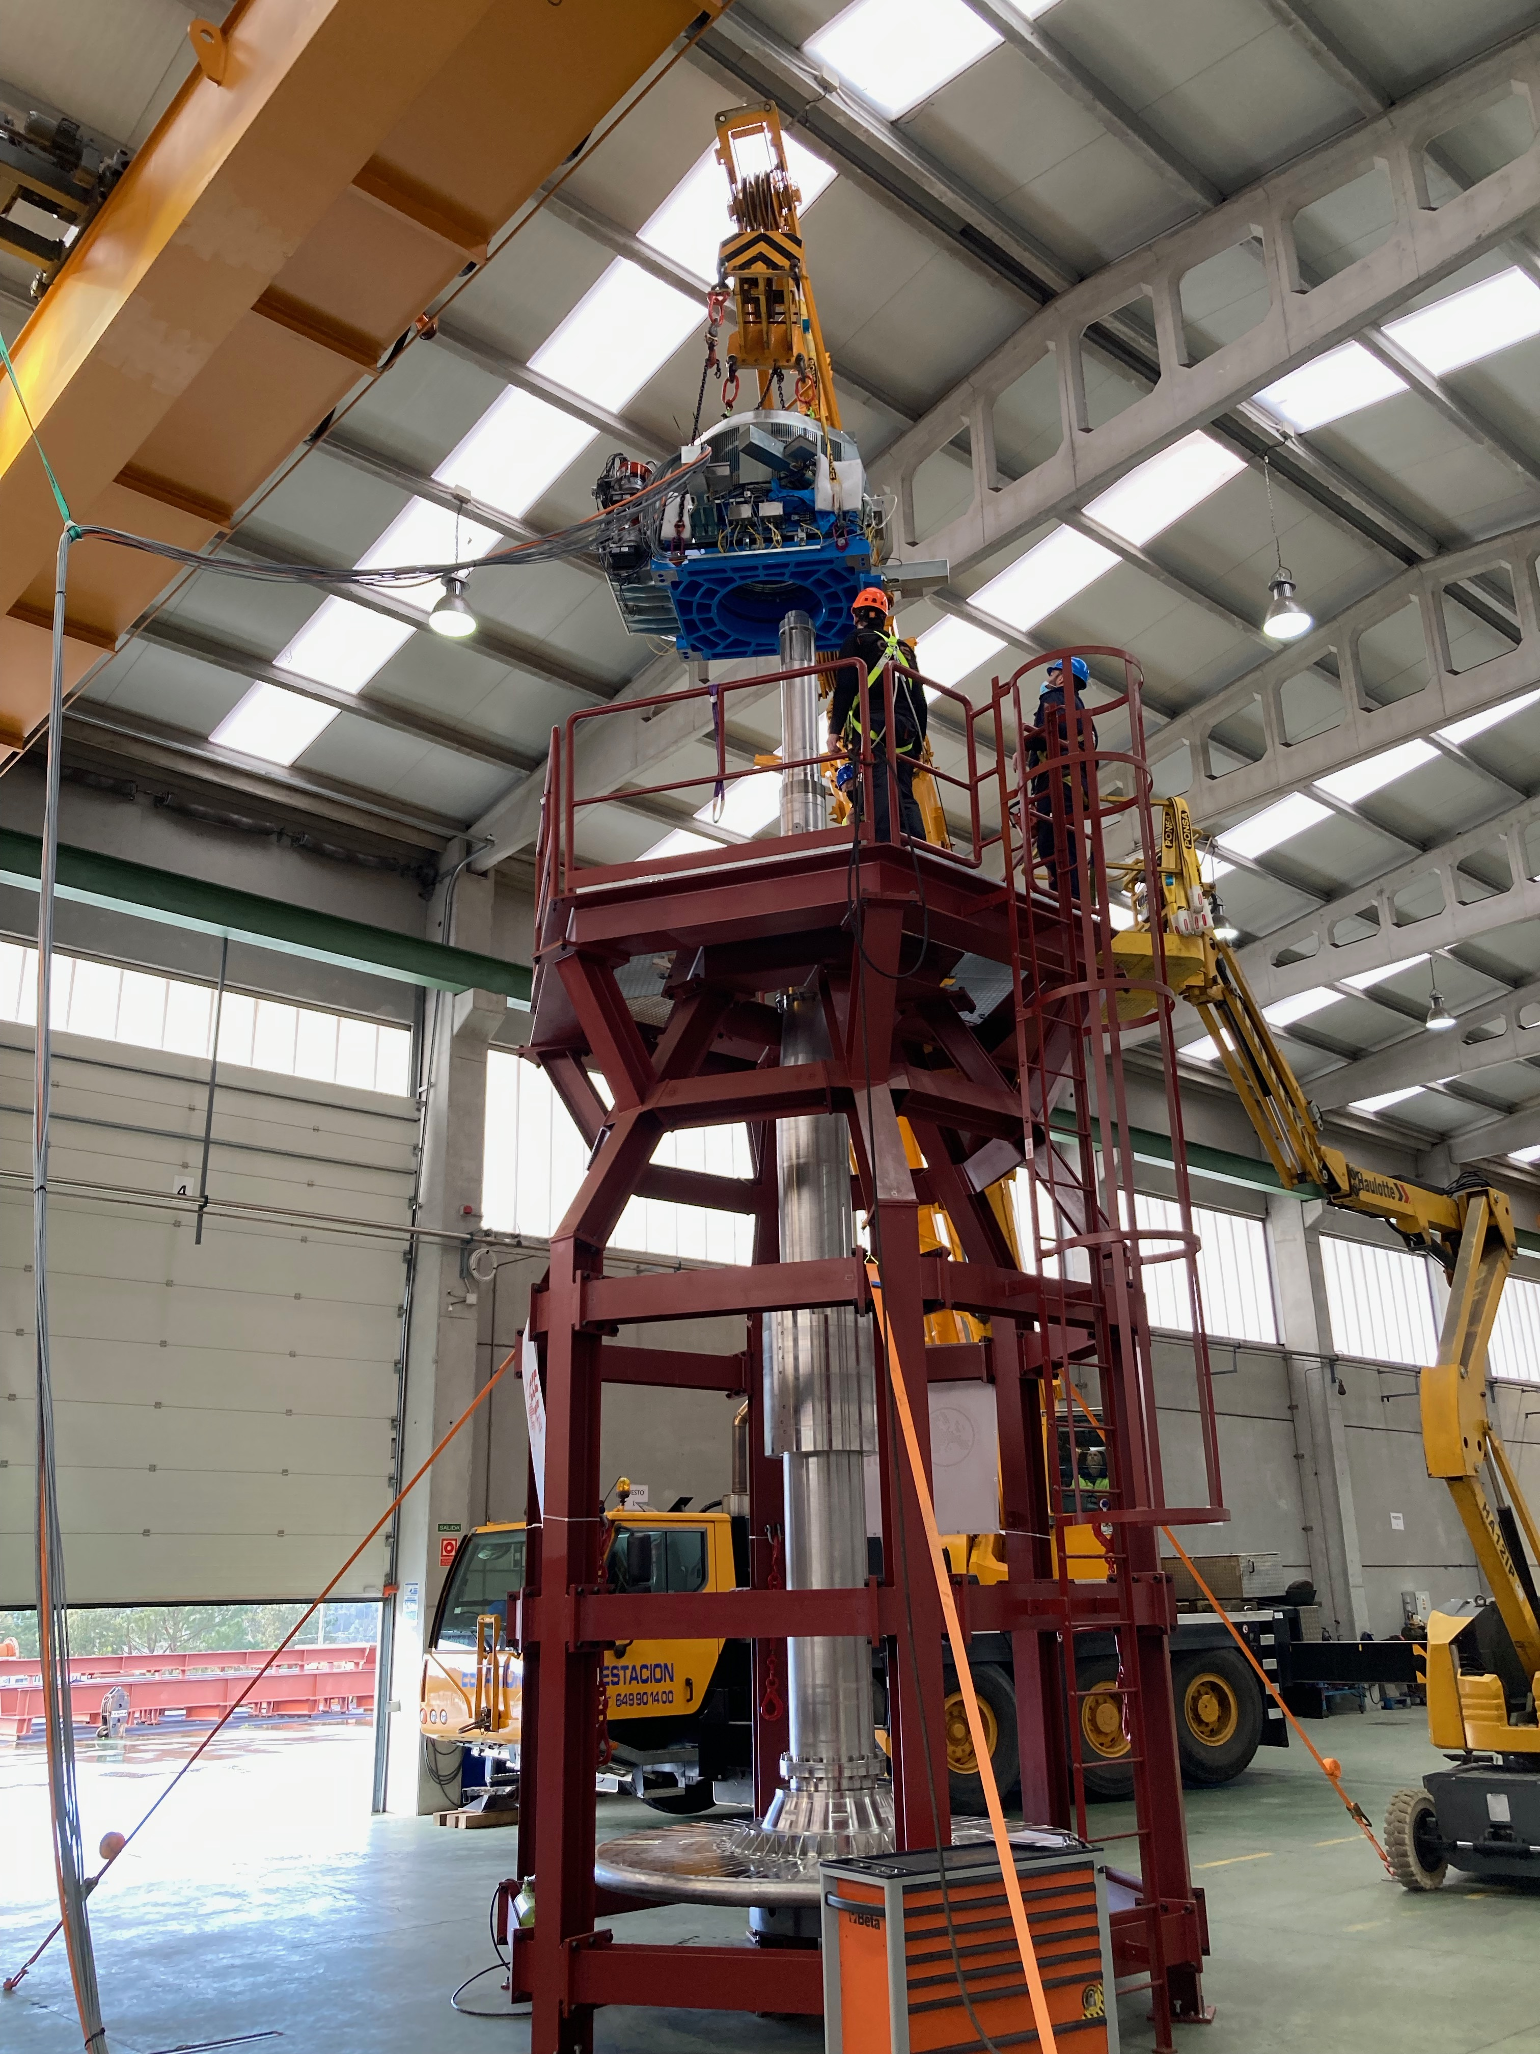

Figure 1: Target wheel, shaft and drive unit

# Control and Measurement SYSTEMs

## Measurement system

The FAT measurements were performed with an EtherCAT [1] based control system, ecmc [2]. The configuration files for the SAT have been added to a git repository [3]. All hardware needed for the tests have been integrated into the same system which then leads to that all sampled data have the same time base.

The actual control of the X,Y,Z and rotational motors was handled with other control system.

## Hardware

The following control hardware was used, Figure 2:

1. EL5021: 1ch sin/cos encoder interface for Amo rotational eddy current sensor
2. EL3174: 4ch analog input for Telemess eddy current sensors [5]
3. ILD2300: Micro Epsilon laser triangulation sensor [4].

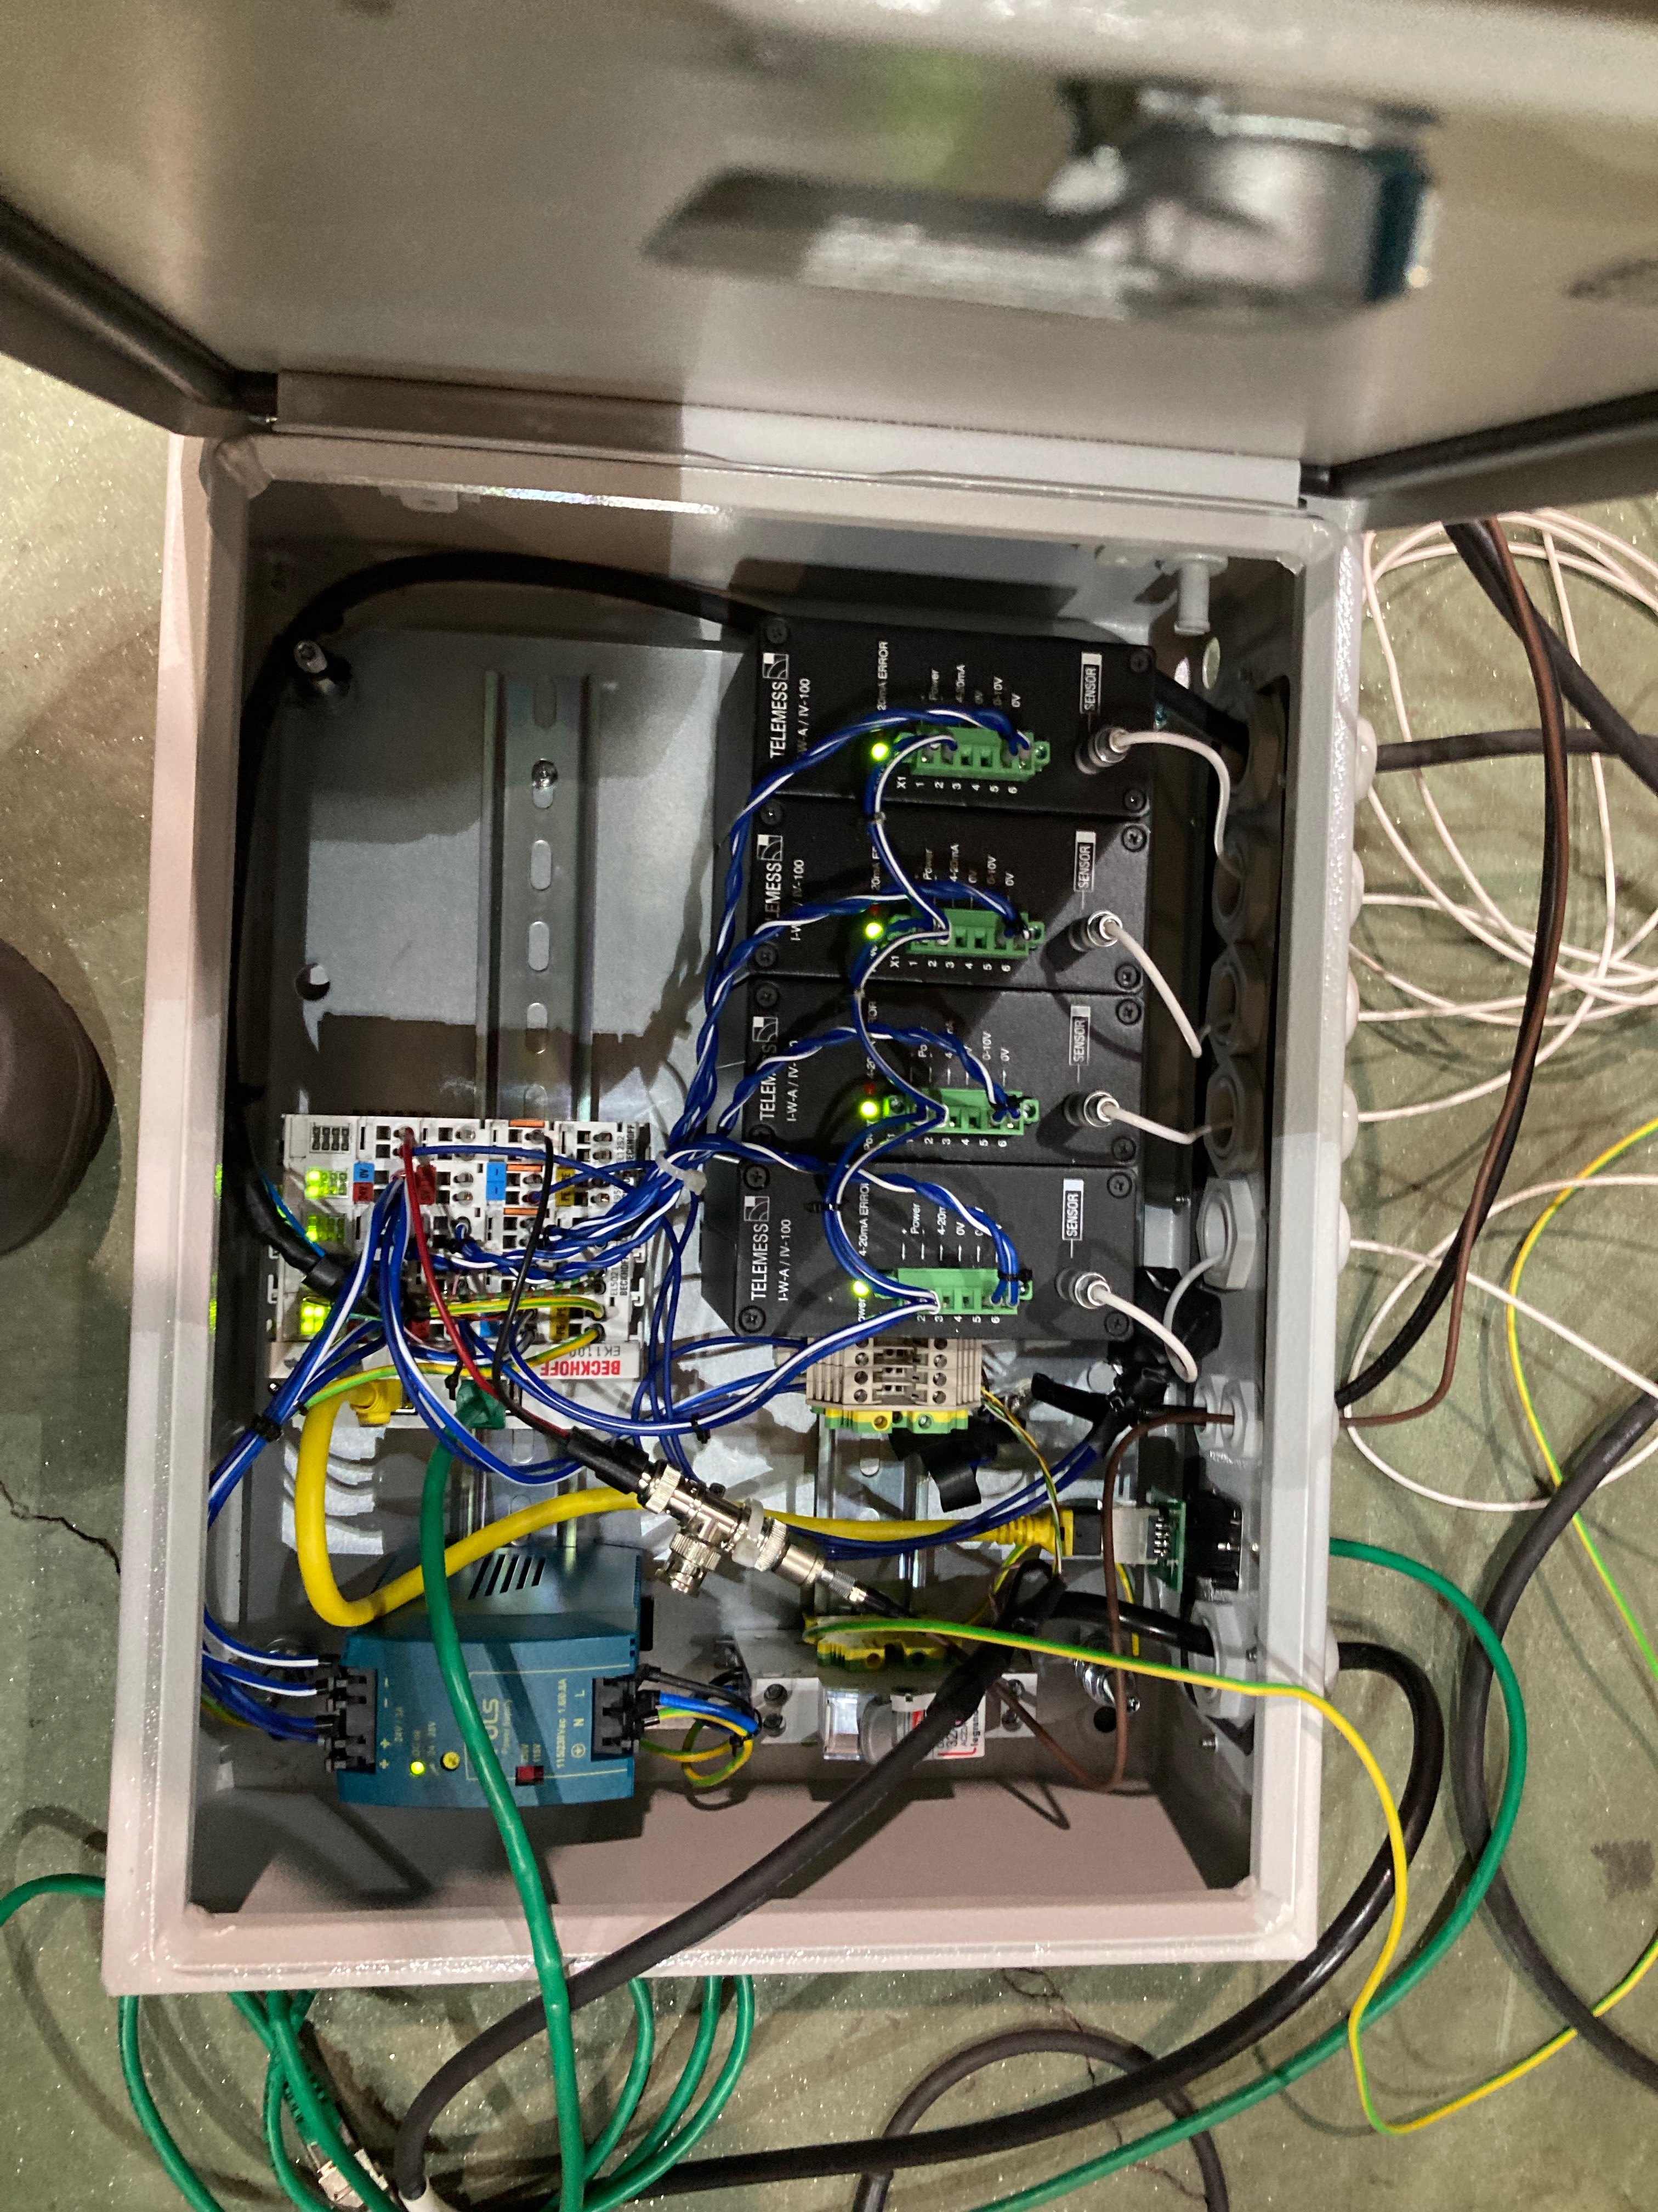

Figure 2: Control hardware

## EL5021 Encoder interface

The EL5021 sin/cos interface was connected to one of the two AMO rotational encoder of the target wheel measuring rotational position, Figure 3.

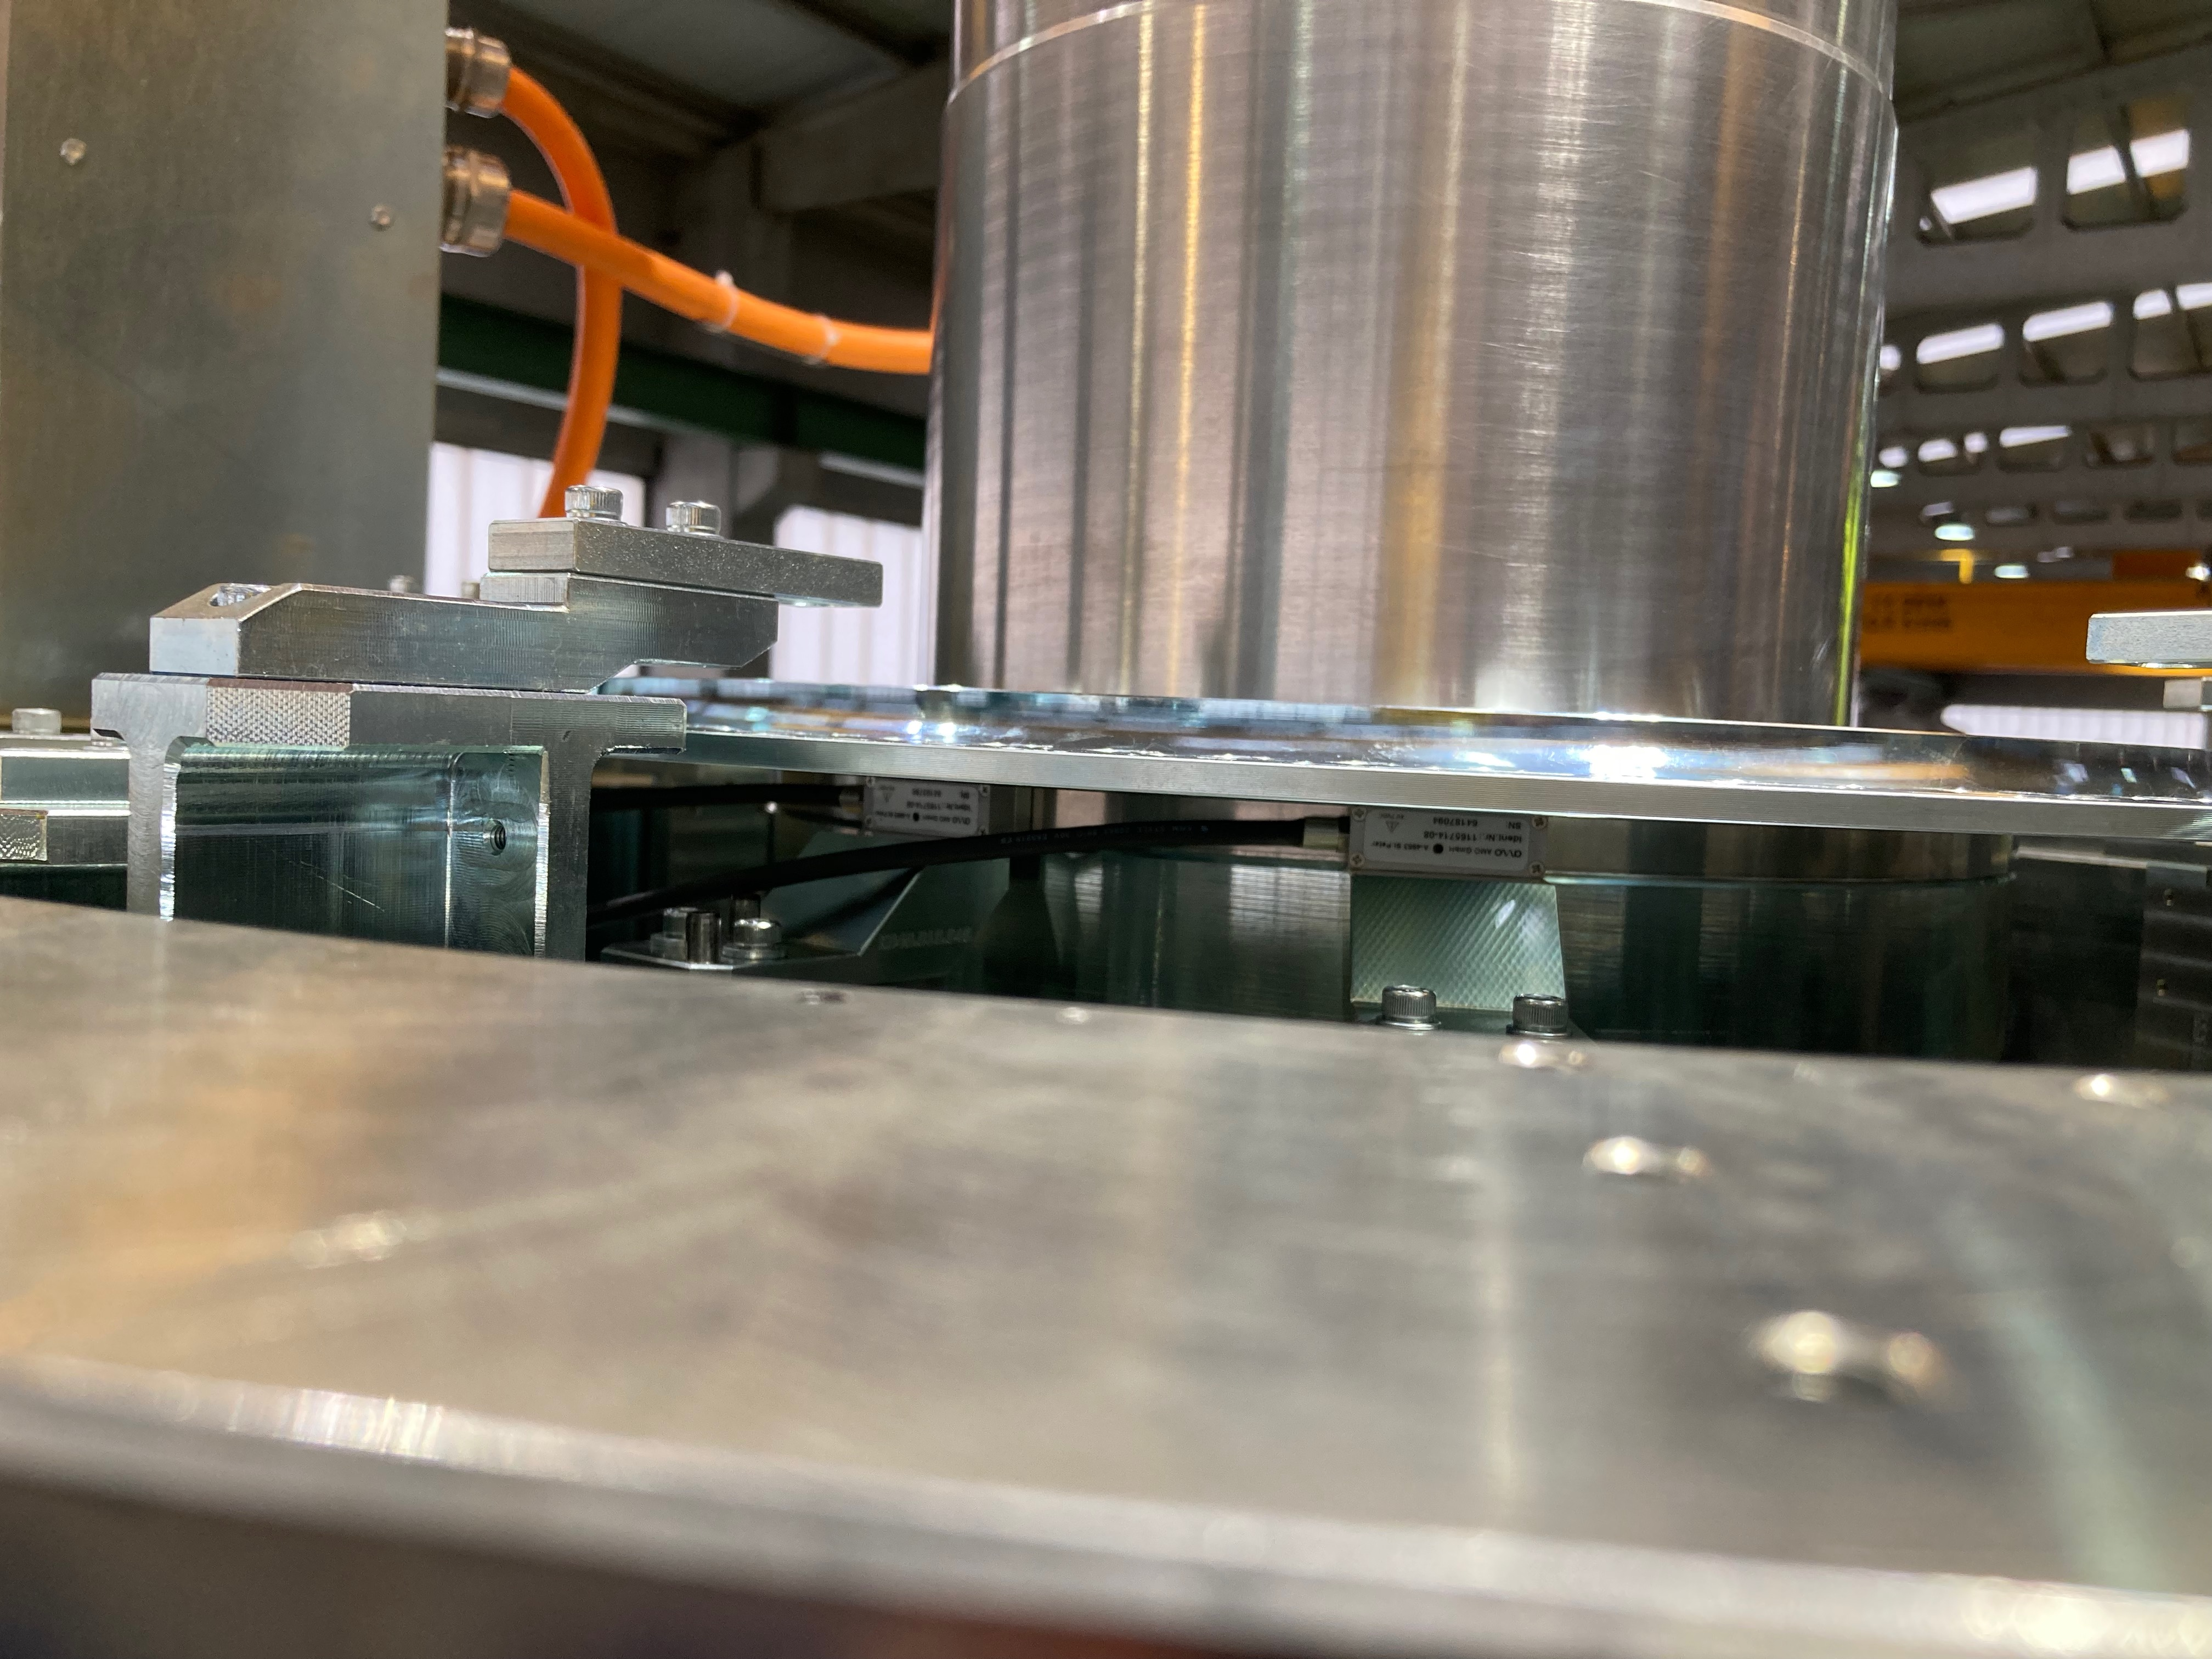

Figure 3: Amo rotational sin/cos encoder

## EL3174 Analog interface

The EL3174 analog interface was used to interface 4 Telemess analog eddy current position sensors. Three sensors of type A30-S01, Appendix B: Telemess A30-S01, were mounted in the horizontal plane with an angular offset of 120 degrees, the fourth sensor of type A42, APPENDIX C: Telemess A42, was mounted vertically from underneath the pedestal, Figure 4.

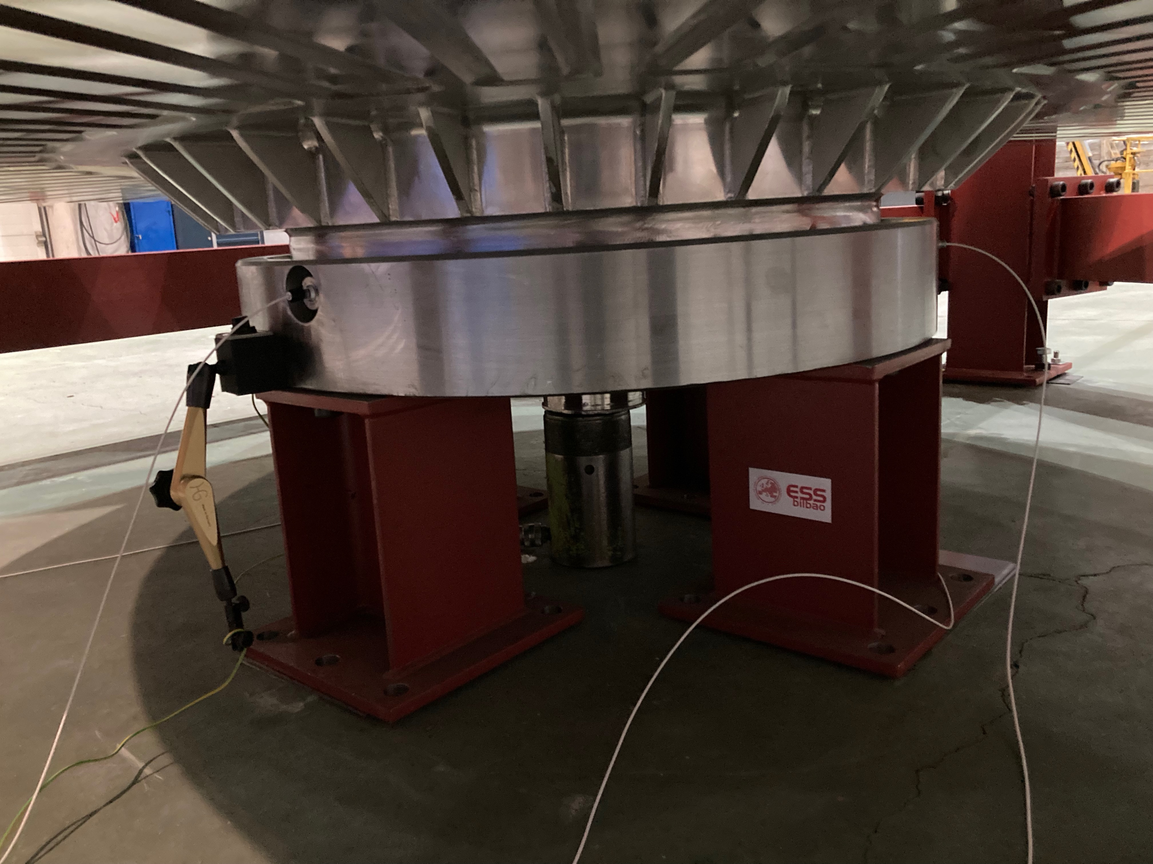

Figure 4: Telemess eddy current sensor positions

The sensor signals were all linearized according in the control system based on calibration data sheets from the supplier, [6].

## ILD2300 Position sensor

The ILD2300 optical triangulation sensor was mounted to measure directly on the circumference of the target wheel, Figure 5.

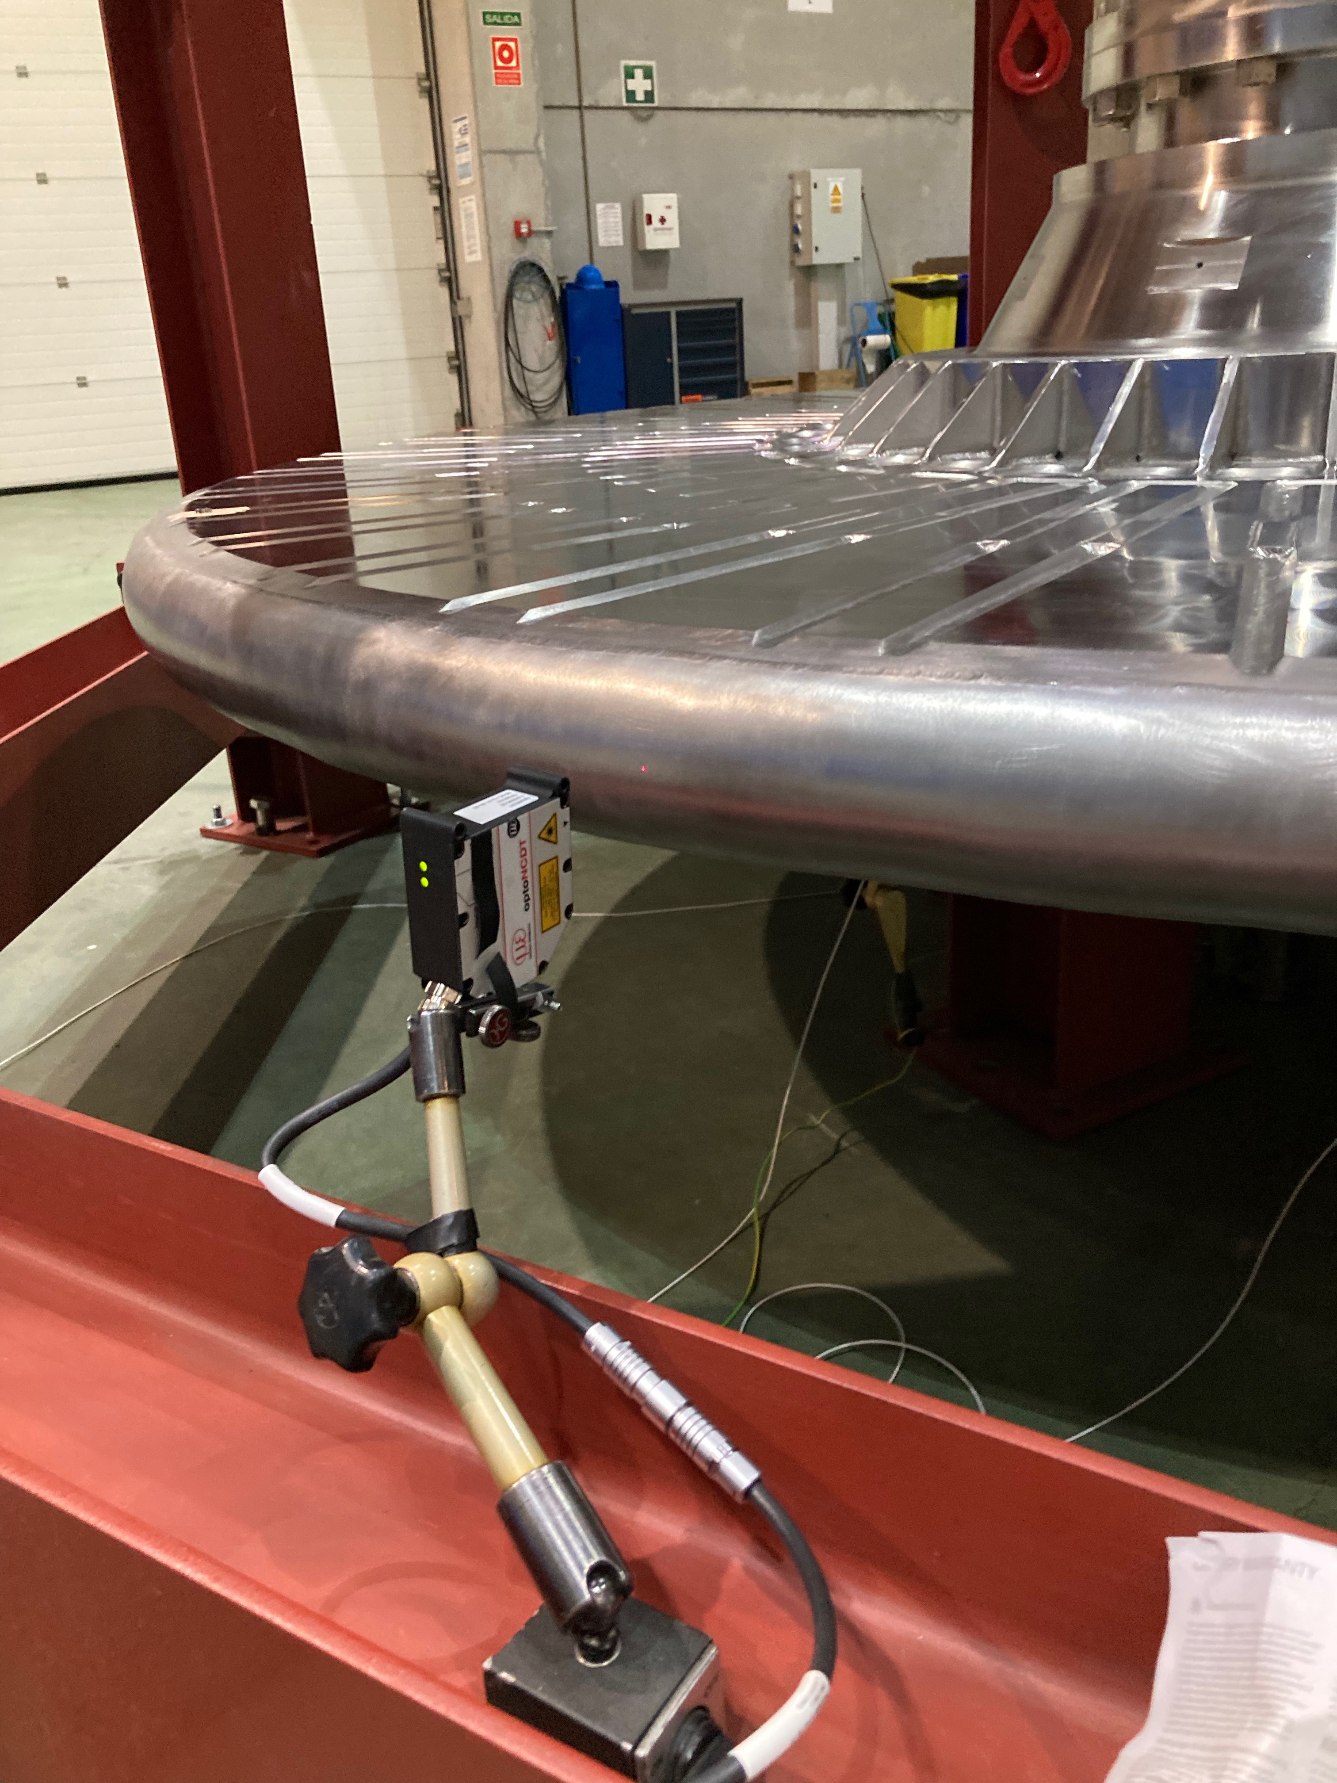

Figure 5: ILD2300 triangulation sensor

The Micro Epsilon ILD2300 sensor interfaces directly over and have the following specs:

1. Range: 50mm
2. Linearity: +-10 μm (protocol: Appendix A Micro Epsilon ILD2300 Calibration)
3. Resolution: 0.8 μm

## Control system for rotational drive

AVS was in charge of controlling the rotational motion. This was done by a standalone drive integrated into a control box, Figure 6. Rexroth Indra drive hardware and software was used to control the drive [8].

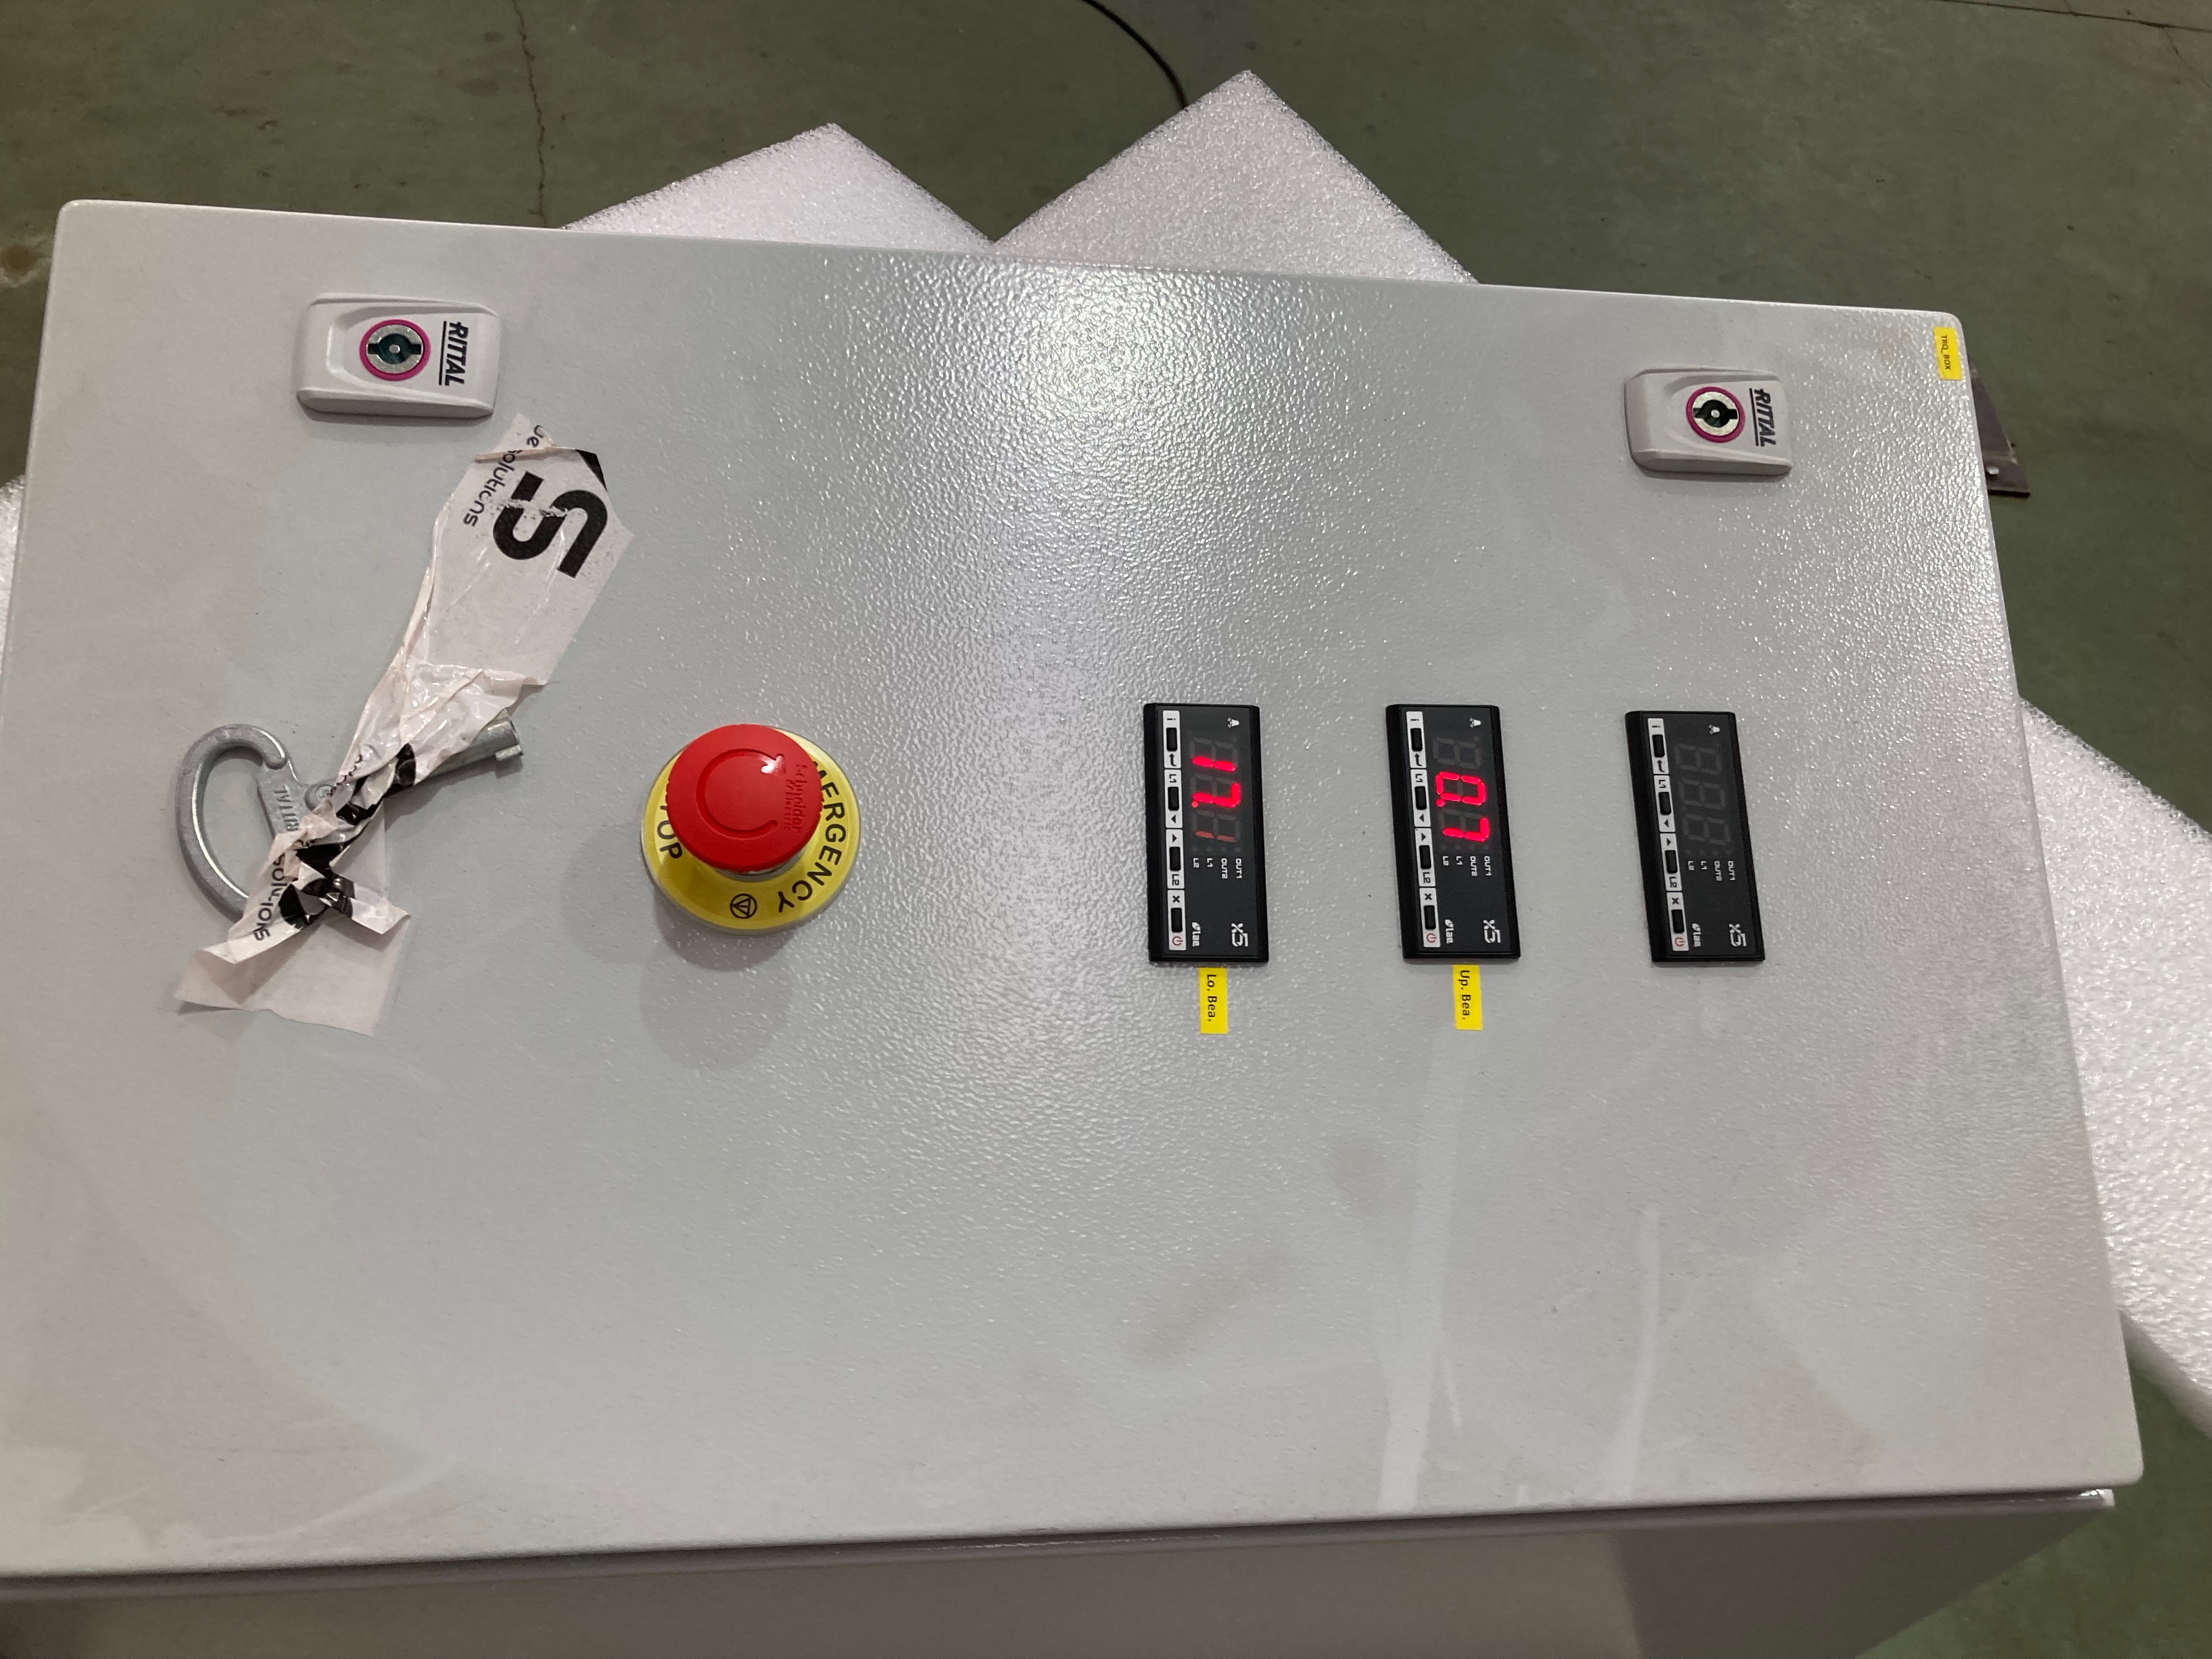

Figure 6: Control box for rotational motor (Rexroth)

## Control system for stepper drives

AVS was also in charge of controlling the stepper motors, Figure 7.

The steppers were controlled with ecmc software, [2] and a CS-Studio HMI, Figure 8.

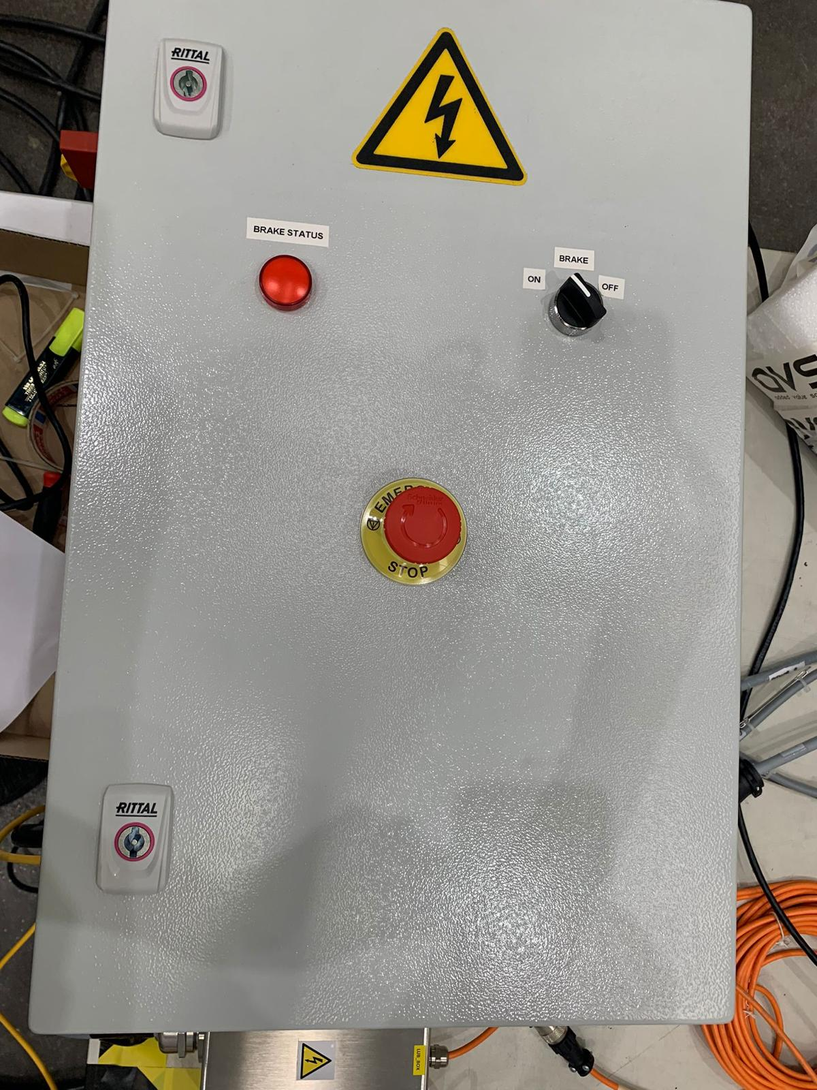 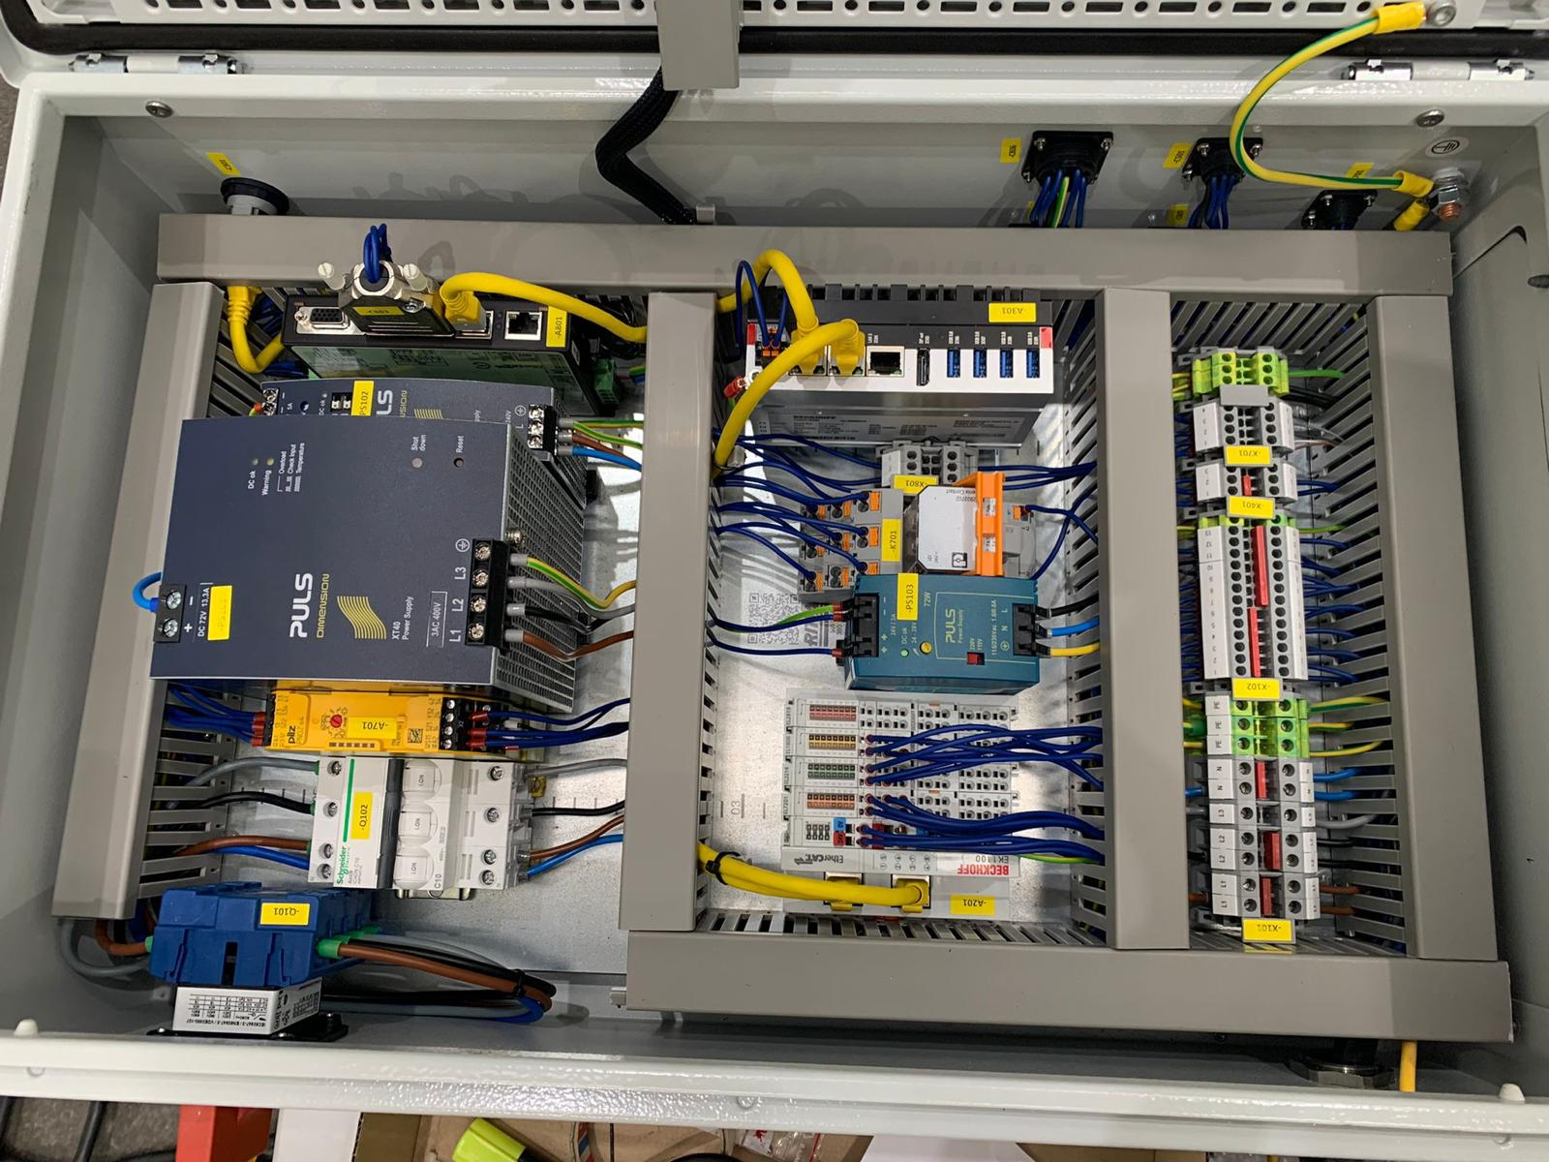

Figure 7: Control box for stepper motors

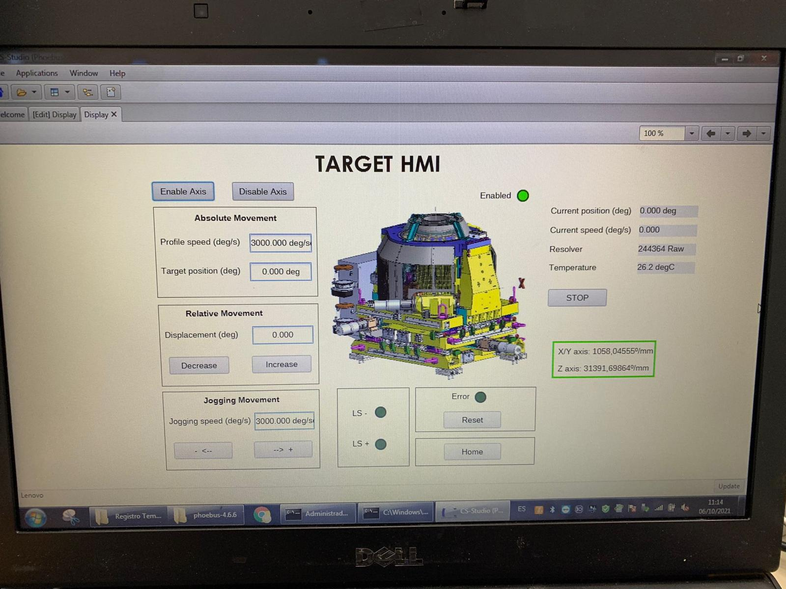

Figure 8: CS-Studio HMI

# Test Execution

The FAT was performed during week 7, 2022 at Thune Eureka premises in Galicia. The activities for each day of the week was:

* Monday: Assembly of drive unit and commissioning of control and measurement systems
* Tuesday: Continue commissioning of control and measurement systems, test rotation and x,y,z stepper movements.
* Wednesday: 12h rotation test
* Thursday: Focus on x, y, z stepper axes tests and some rotation tests
* Friday: Disassembly and preparation for shipment of components to Lund.

## Monday

The drive unit was prepared and lifted into place on the frame and shaft, Figure 2.

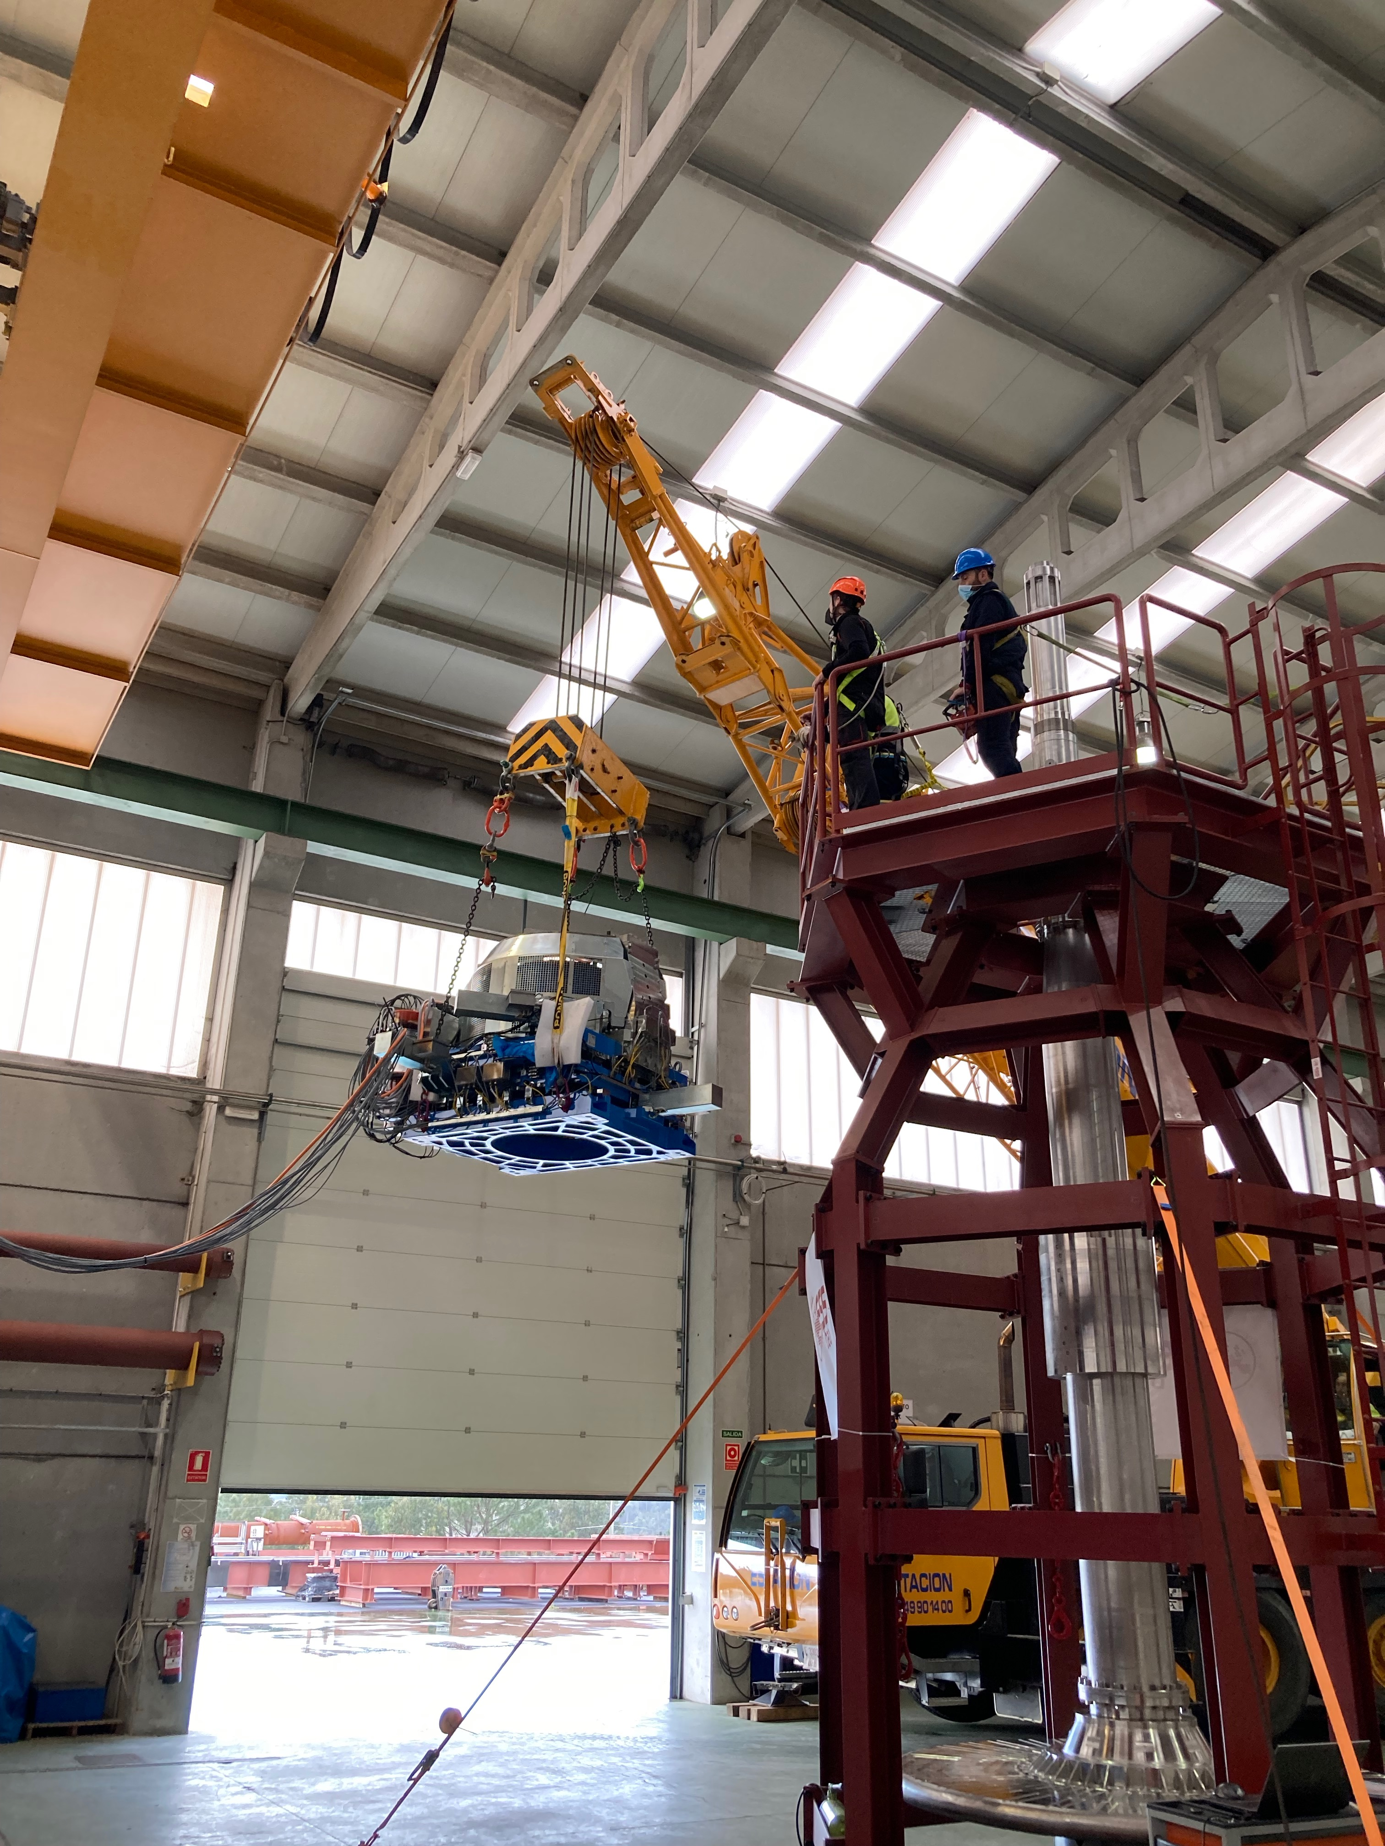 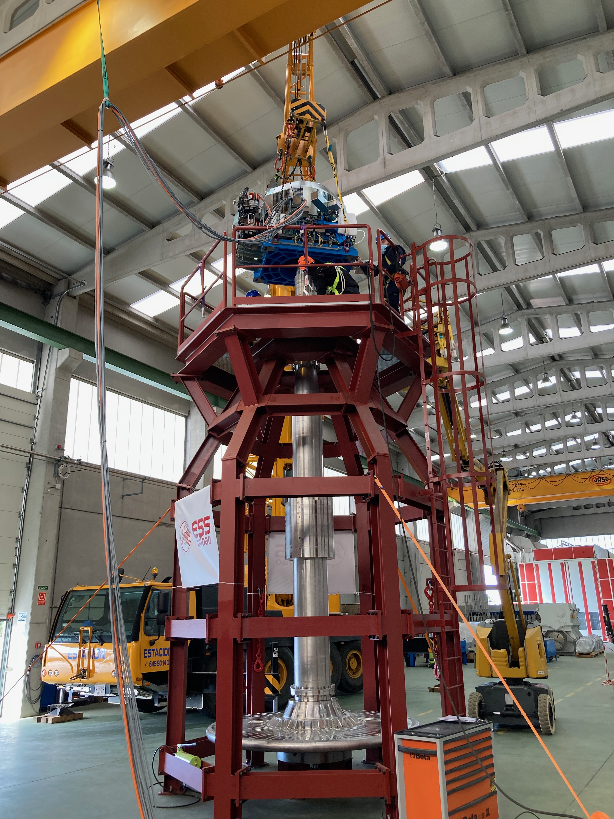

Figure 9: Drive-unit mounting

## Tuesday

### Assembly

The assembly of the drive unit was finalized with mounting of, Figure 3:

* encoders
* notch wheel
* slip ring

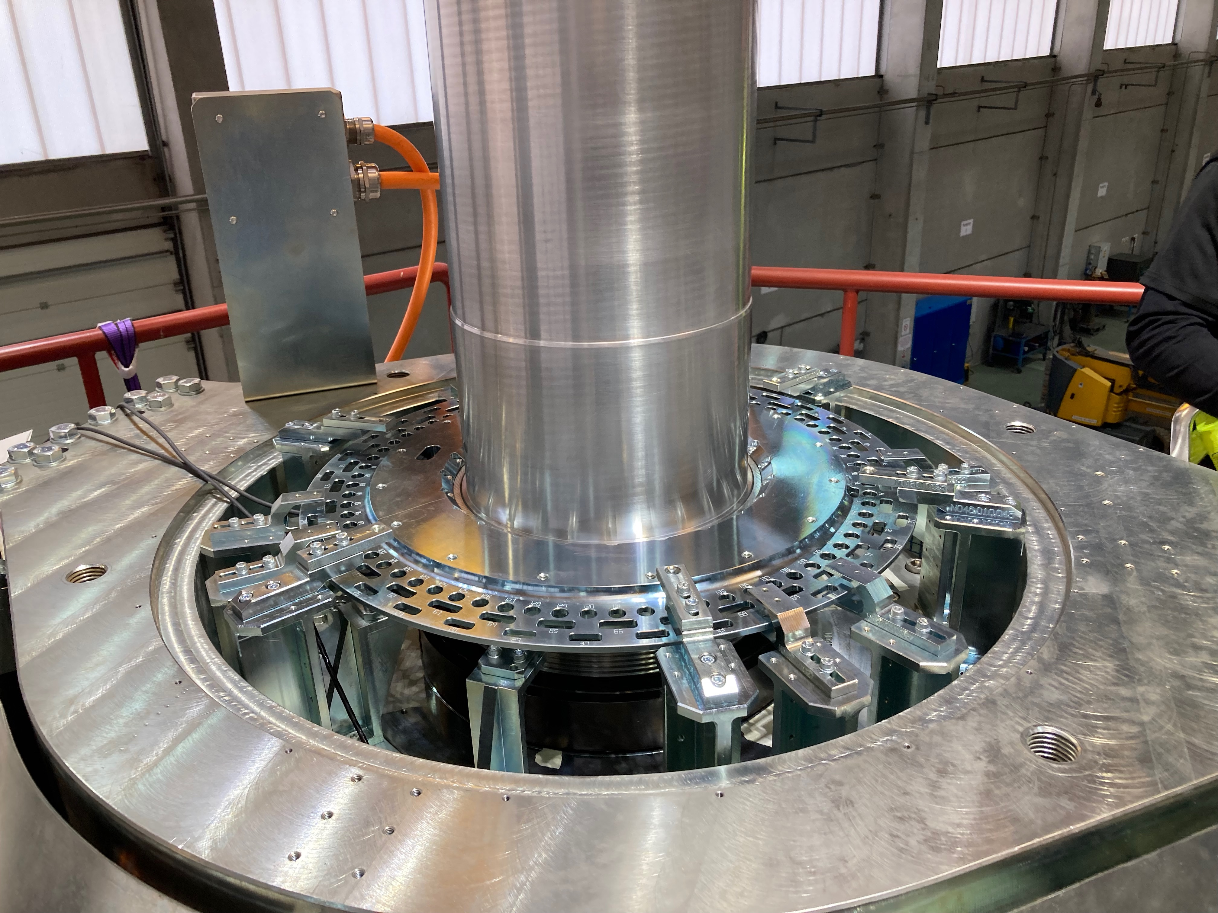

Figure 10: Notch wheel and encoders

### Commissioning

After assembly, commissioning of control and measurement systems started:

* Sensors was mounted
* Signal checks of all equipment
* Grounding checks

During the signal checks it was discovered that the Telemess eddy current sensors, [5] and [6], were giving incorrect signals (scale and offset). After some tests it was apparent that the sensors were not calibrated for measuring on stainless steel but for use with normal steel, (even though supplier guaranteed they should work on stainless steel). As a workaround the sensors were recalibrated by use of the optical triangulation sensor [4], the scale factor was found to be 0.738 resulting in comparable results. Another implication was that the measurement range was then also shorter than specified so the sensors had to be mounted closer to the wheel in order to get within range. Sensors will need to be sent to manufacturer for new calibration before MUTS tests.

Data recorded during standstill but with people working on the platform show that the frame and target wheel assembly have one resonance frequency in the region of 1 Hz, Figure 8.

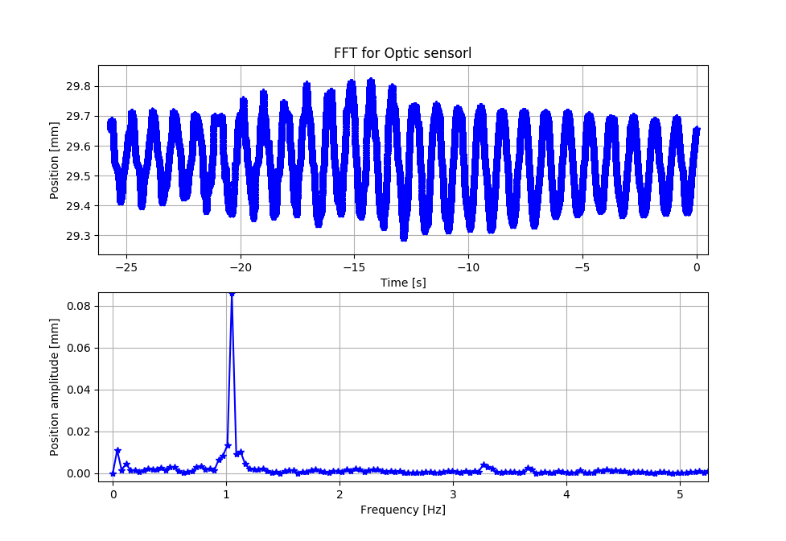

Figure 11: Target wheel position relative frame at standstill

Even though the frame looks sturdy just by giving it a gentle push the movement of the target wheel could easily be identified in the data from the sensors.

### First rotation

At first rotation AVS discovered that an rpm setpoint with decimals was not possible to enter into the system. Therefore, it was decided that all tests which should run. At nominal speed 23.333rpm should be performed at 24rpm instead.

Shortly after the start the drive was going into error state because of wrong encoder signals at least once per turn resulting in stop of motion. In order to isolate the problem, the main drive encoder was connected to the measurement system described in chapter 3. The encoder value was read without any issue by the measurement system. The issue could then be isolated to cabling or something related to the drive control box:

* Cabling
* Disturbances

**Cabling**:

Cable was checked with multi-meter and was found to be correct.

**Disturbances**:

The encoder cable was separated from power cables but without improving the situation. Finally, one or the Thune Eureka engineers remembered that they previously had issues with a machine connected to the same power supply used by the drive control box. After switching to another power outlet, the encoder signal was stable. Most likely the first outlet did to make a correct connection to ground.

The rest of the day was used for rotation tests at different velocities, see chapter 6 for a detailed analysis.

### Wednesday

The entire Wednesday was used for a10h test of rotation at 24rpm. At approx. 16:11 the wheel was unintentionally stopped but restarted directly again. Detailed analysis of the data acquired this 10h test can be found in chapter 5.

### Thursday

Thursday started with a few rotational tests then the rest of the day was focusing on the X, Y, and Z stepper axis movements.

Like mentioned in chapter 4.2.2, the Telemess sensors, [5], was mounted closer to the target wheel than intended resulting in a risk of collision when running the X and Y stepper motors. In order to prevent collision, the sensors were removed. The optical sensor was positioned to measure in the same position as the Telemess 120º sensor.

# Analysis: Rotation velocity stability

This chapter focuses on analysis of rotation velocity. The data analysed is extracted from different parts of the 3 test days. A complete analysis of the 10h test on Wednesday can be found in chapter 6.

## Method

Encoder angular position data was recorded during all tests. The encoder input terminal, 2.3, was configured to reset position to zero each time receiving the index pulse, occurring once per revolution when the index mark is encountered by the encoder reading head. Thereby all recorded encoder angular position values are absolute in relation to the index pulse and are therefore consistent during all tests.

In order to calculate velocity, the position values were differentiated over time and averaged over one sector, 10 degrees, to reduce noise.

Detailed analysis of the velocity has been done in the following situations:

* Velocity ramp-up
* Constant velocity
* Velocity ramp-down

## Velocity ramp-up

Encoder angular position and velocity for ramp up is presented in Figure 19 and Figure 20. Figure 19 shows the first part of the ramp up, between 6rpm and 22rpm and Figure 20 show ramp up from 22 to 28rpm. Each figure contains 3 graphs, where the lower graph shows angular position, the centre graph shows the calculated velocity, and the upper graph show velocity without linear acceleration component (subtracted linear component). Each red vertical line indicates one full revolution.

From the upper graphs in Figure 19 and Figure 20 it can be concluded that the velocity oscillates in the beginning of the ramp-up phase but stabilizes in the region between 10rpm to 18rpm. Above 18rpms the oscillation in velocity increases and peaks at approx. 22-23rpm. At higher velocities the amplitude of the oscillations decreases again slightly. The peak of the oscillations is occurring at an unfortunate frequency range since operational velocity of the target wheel is within or close to this range, 23.3rpm.

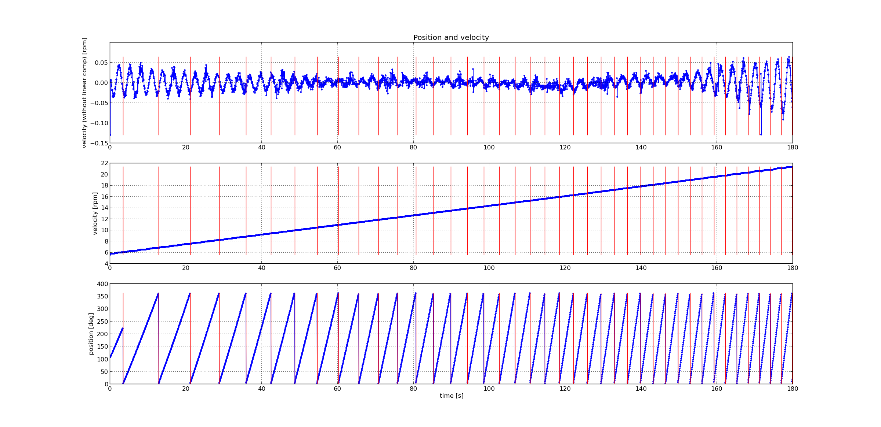

Figure 12: Ramp up 6 to 22 rpm (lower = position, center=velocity, upper=velocity-minus linear component)

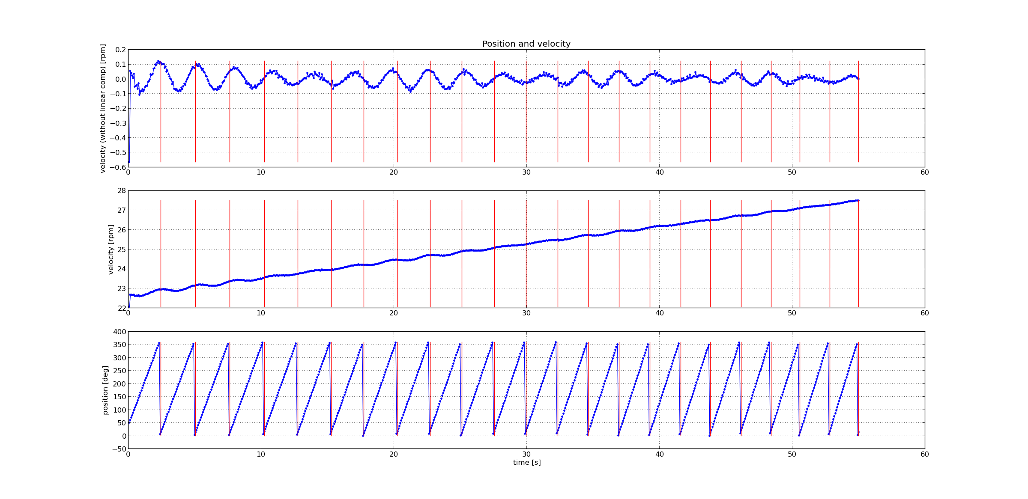

Figure 13: Ramp up 22 to 28 rpm (lower = position, center=velocity, upper=velocity-minus linear component)

## Constant velocity

Figure 21 show position and velocity variation when running at constant 24rpm on Wednesday morning. Figure 22 show same velocity variation but extracted for each revolution.

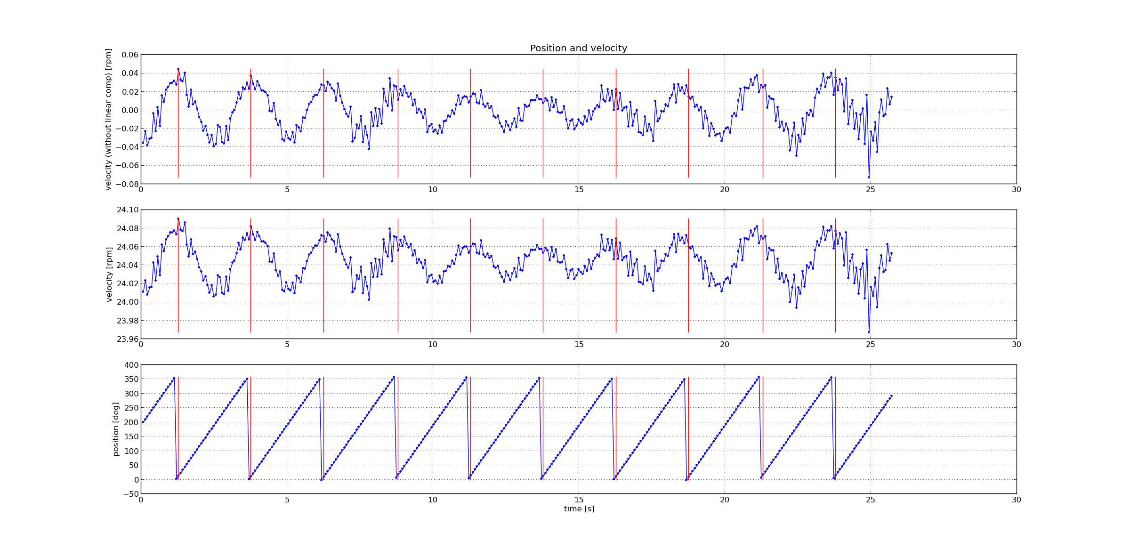

Figure 14: Velocity variation Wednesday morning at 24rpm (lower=position, center=velocity, upper=velocity-minus linear component)

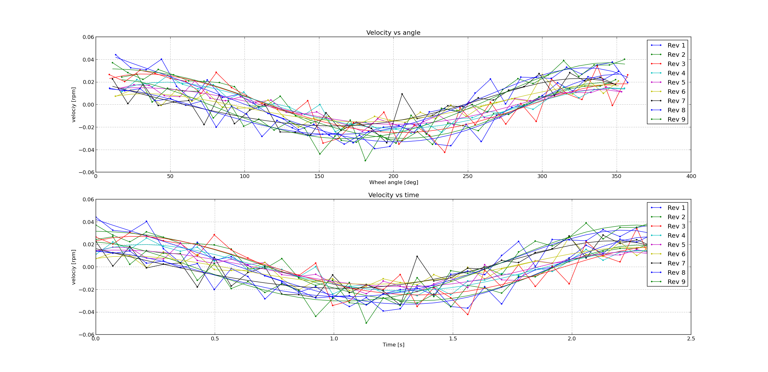

Figure 15: Velocity variation Wednesday morning at 24rpm for each revolution (lower=velocity vs time, upper=velocity vs angle)

Figure 23 show position and velocity variation when running at constant velocity of 24rpm on Wednesday evening. Figure 24 show same velocity variation but extracted for each revolution.

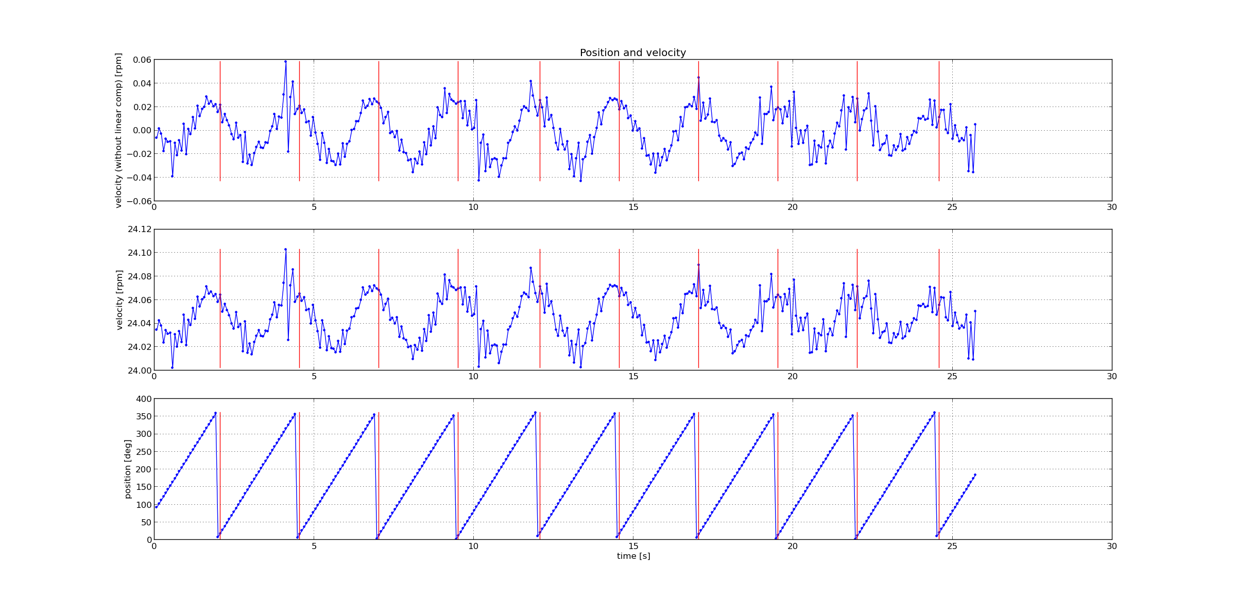

Figure 16: Velocity variation Wednesday evening at 24rpm (lower=position, center=velocity, upper=velocity-minus linear component)

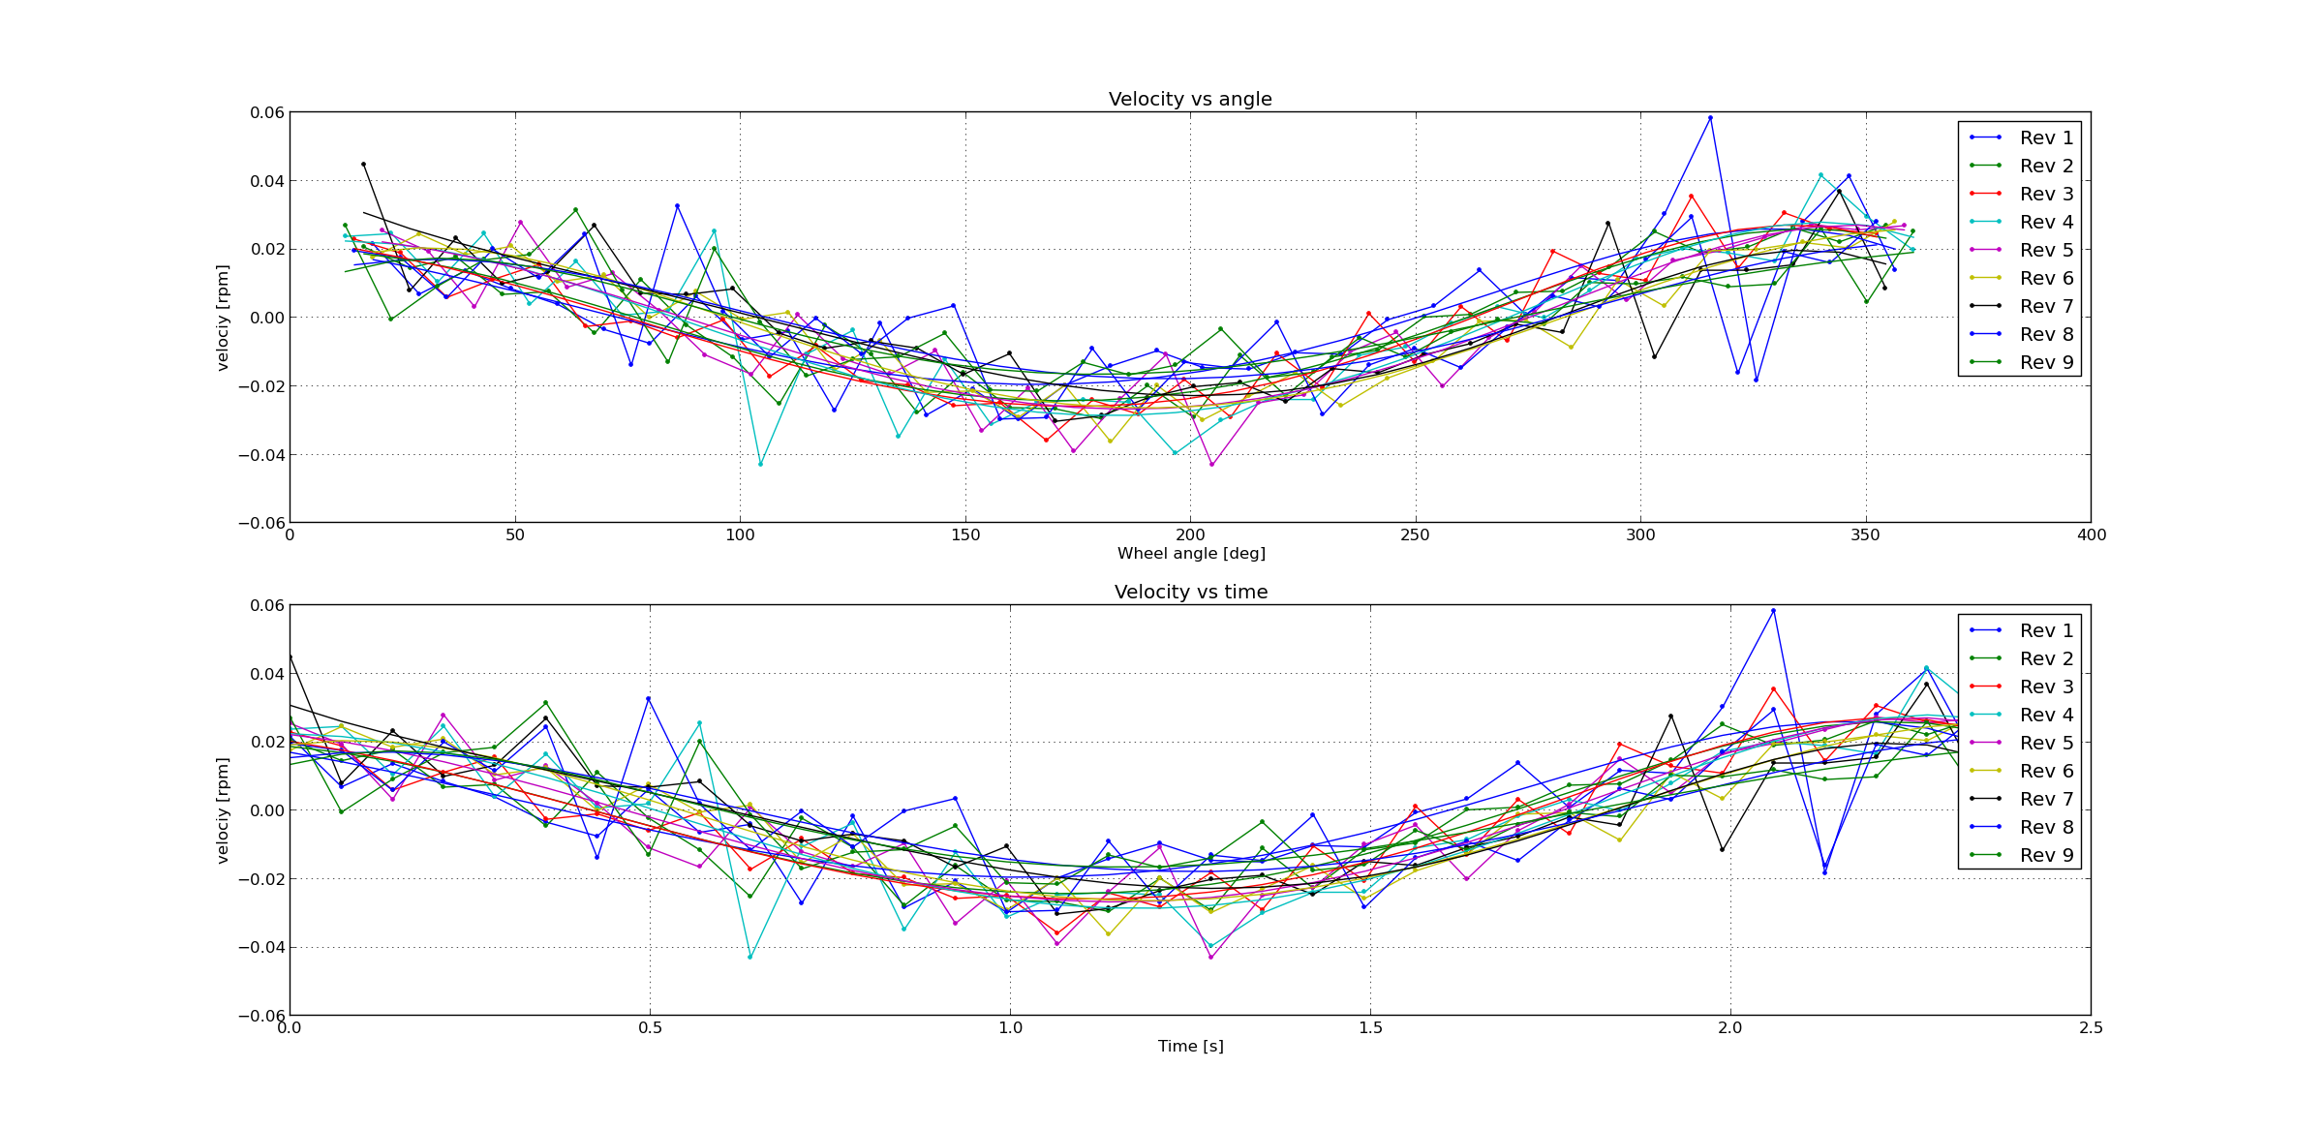

Figure 17: Velocity variation Wednesday evening at 24rpm for each revolution (lower=velocity vs time, upper=velocity vs angle)

Figure 18 show position and velocity variation when running at constant velocity of 28rpm on Wednesday morning. Figure 19 show same velocity variation but extracted for each revolution.

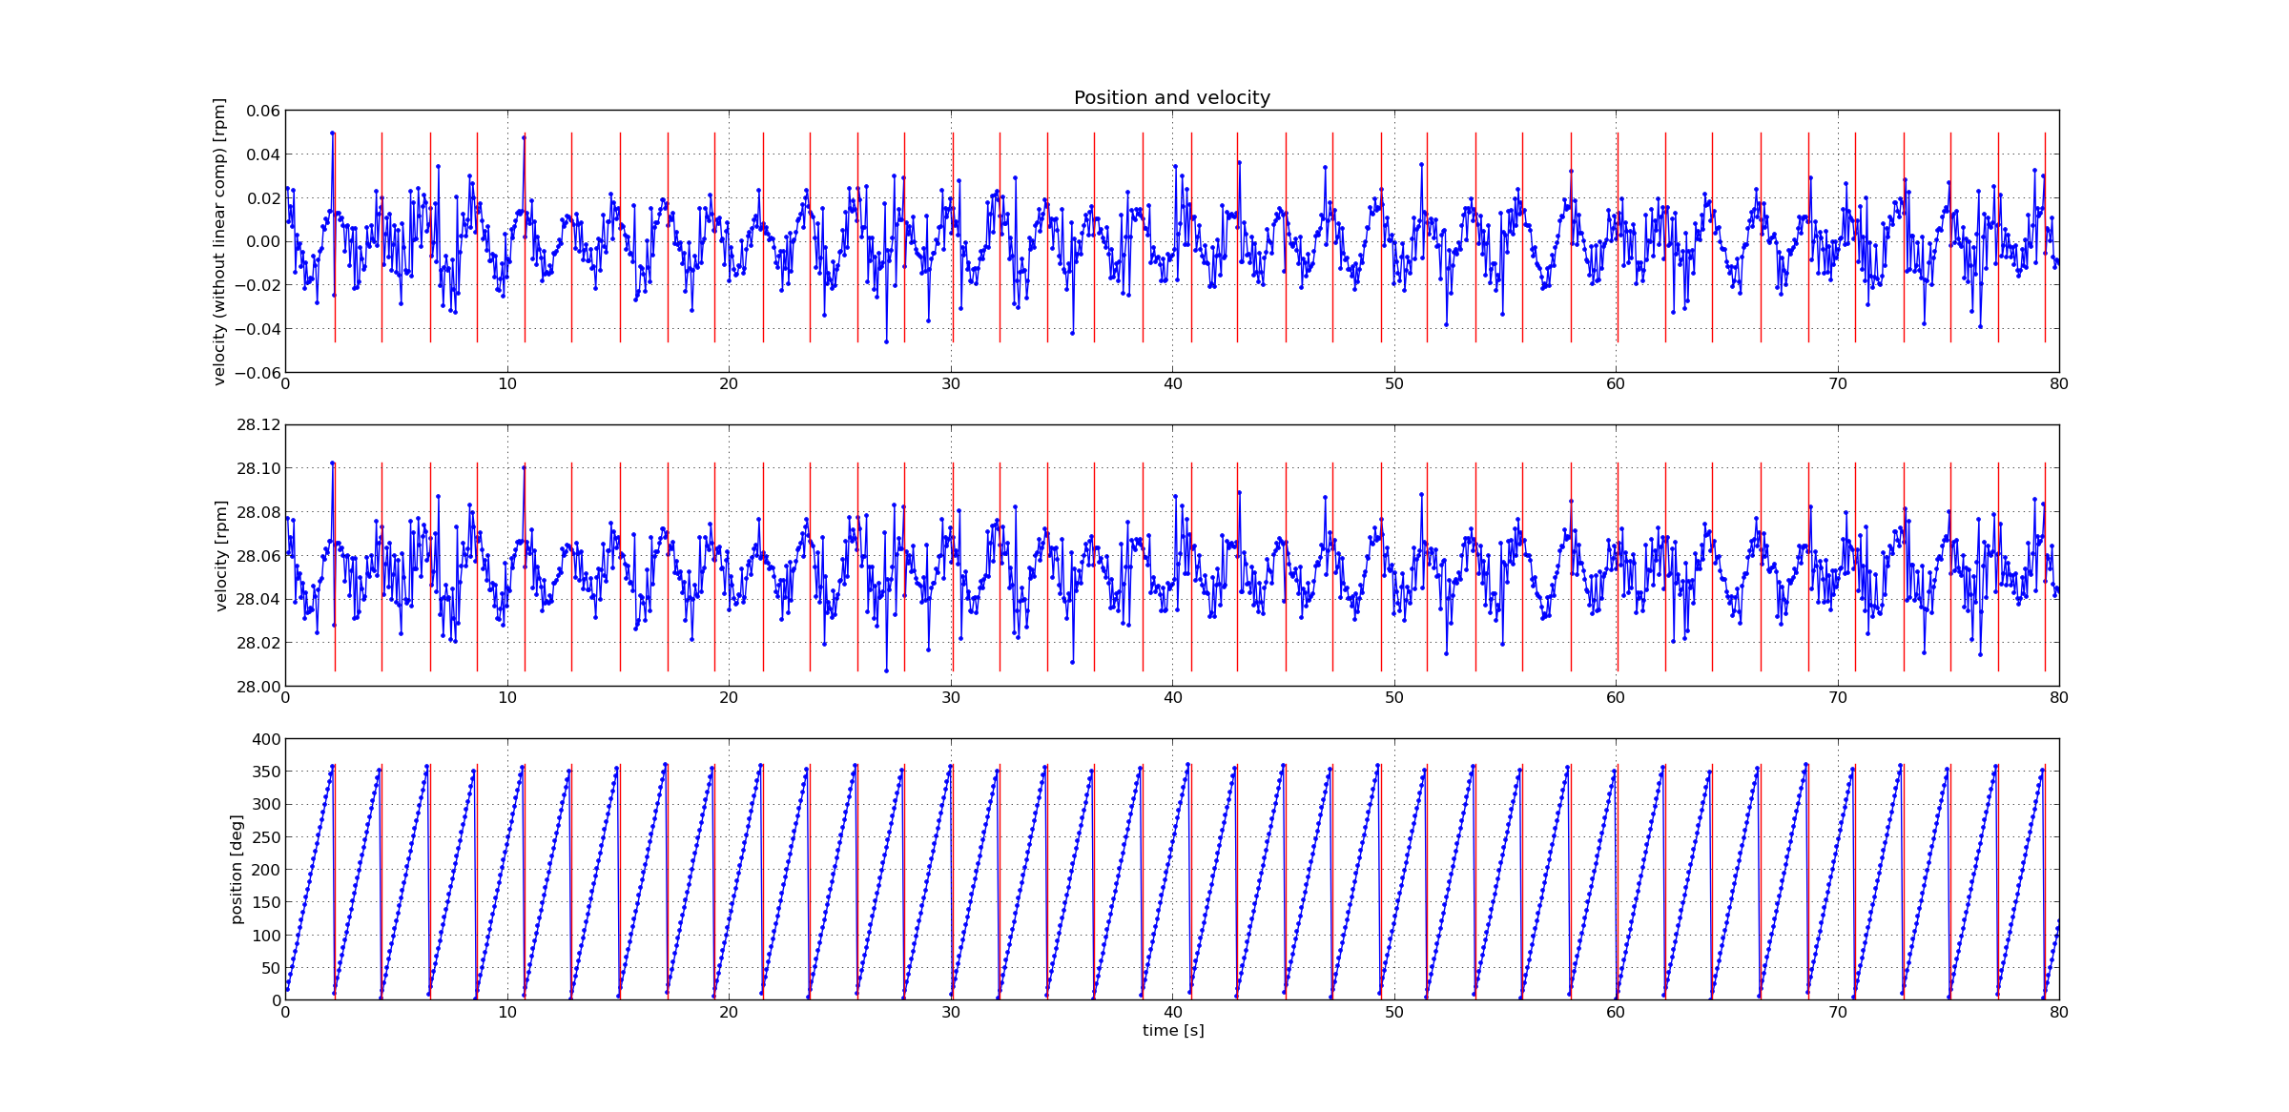

Figure 18: Velocity variation Wednesday morning at 28rpm (lower=position, center=velocity, upper=velocity-minus linear component)

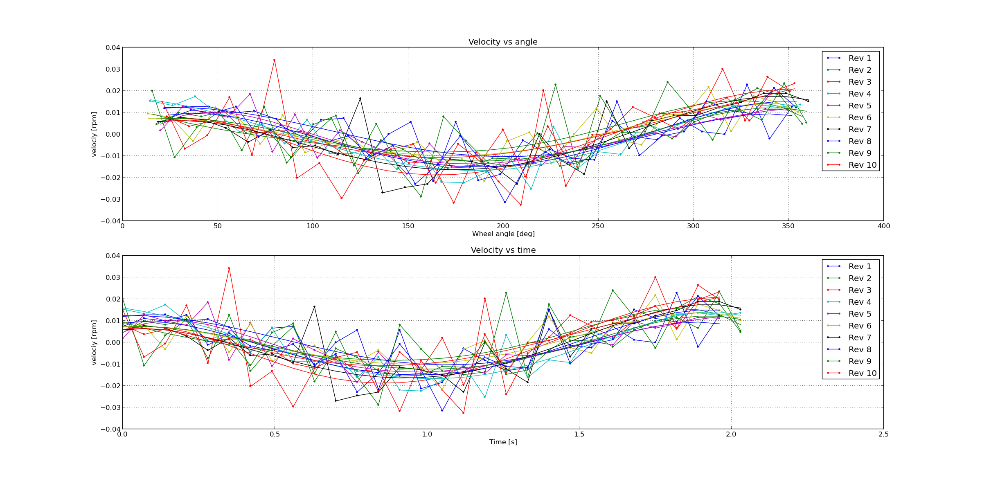

Figure 19: Velocity variation Wednesday morning at 28rpm for each revolution (lower=velocity vs time, upper=velocity vs angle)

Comparing the data sets from Wednesday morning and evening and at different velocities, it can be concluded that the velocity variations are similar in amplitude and phase in relation to wheel angle. In between acquisition of these three data sets, the wheel has been stopped and re-started again. This means that the velocity variations returned to the exact same phase angle after the restarts which indicate a disturbance in traction related to a fix angle of the wheel.

## Velocity ramp-down

Encoder angular position data was sampled during ramp down with motor disabled meaning only the traction in the system, mostly in bearings, and inertia of the rotor will affect the deceleration ramp (no torque on motor).

The lower graph in Figure 3 shows the angular position during ramp down from 23 to 0 rpm in unit degrees. The total time to ramp down from 23rpm to 0 is approximately 94 seconds.

The average traction torque can be calculated by:

$=I*$

τ = Torque [Nm]

I = Inertia [kgm2] = 5260kgm2

α = angular acceleration [rad/s2], 23rpm to 0 rpm in 94s

The average traction torque can then be calculated to approx. 135Nm which also corresponds well to the torque recorded from the drive, chapter 4.1.

It can be concluded from the upper graph that the deceleration is not constant during the ramp down process and also varies cyclically within each revolution, similarly to when motor is in use.



Figure 20: Ramp down from 23 rpm (lower = position, center=velocity, upper=velocity-minus linear component).



Figure 21: Velocity for each rev vs rotation angle and time (linear velocity component removed)

Detailed velocity changes for each revolution from the upper graph in Figure 3 is plotted in Figure 4, the upper graph shows velocity vs angular position and the lower graph shows velocity vs time. A polynomial fit for the dataset of each revolution is also plotted in the same color as the raw velocity data. All revolutions show a similar shape where in the first part of the revolution the deceleration is faster than in the second part of the revolution. This could be an indication that the traction torque is not same over the revolution. By analyzing the slope of polynomial fits it can be concluded that the torque difference within the revolution is in the order of at least +-10Nm in average for the analyzed revolutions, with a clear trend for higher torque variations for the revolutions at higher velocities. Another reason for this velocity change could be that the whole frame is oscillating resulting in cyclic displacement of the encoder reading head and therefore a cyclic overloaded sinusoidal disturbance in the encoder position.

A similar test but ramping down from 28rpms is shown in, Figure 9, Figure 10. Unfortunately, the data logging was stopped at 1rpm.



Figure 22: Ramp down from 28 rpm (lower = position, center=velocity, upper=velocity-minus linear component).



Figure 23: Velocity for each rev vs rotation angle and time (linear velocity component removed)

The ramp down from 28rpm shows similar behavior to the ramp down from 23rpm.

The phase angle of the velocity variation is also in agreement with the previous tests at constant velocity, chapter 5.2.

## Summary velocity variations

* Variations in velocity is highest during ramp-up in the velocity range 22-23rpm which seems to be a critical speed for the system. In this velocity range the maximum amplitude of the velocity oscillation is approx. +-0.12rpm.
* For constant velocity, at 24rpm and 28rpm, the variation in velocity was measured to be within +-0.06rpm. For the actual nominal velocity of 23.33 rpm the velocity oscillation amplitude is probably higher since it’s closer to the critical frequency. Unfortunately, 24rpm was chosen as nominal velocity, see chapter 3.2.3, because of limitations in the drive setup.
* The oscillation in velocity has the same frequency as the rotation frequency.
* The phase of the velocity oscillation was found to be the same in relation to wheel angle independent of velocity, acceleration, deceleration or starts and stops in between measurements. This indicate that
* The variation in velocity is also present without torque on the motor during ramp down.

# Analysis: Rotor Displacement

## Velocity ramp-up

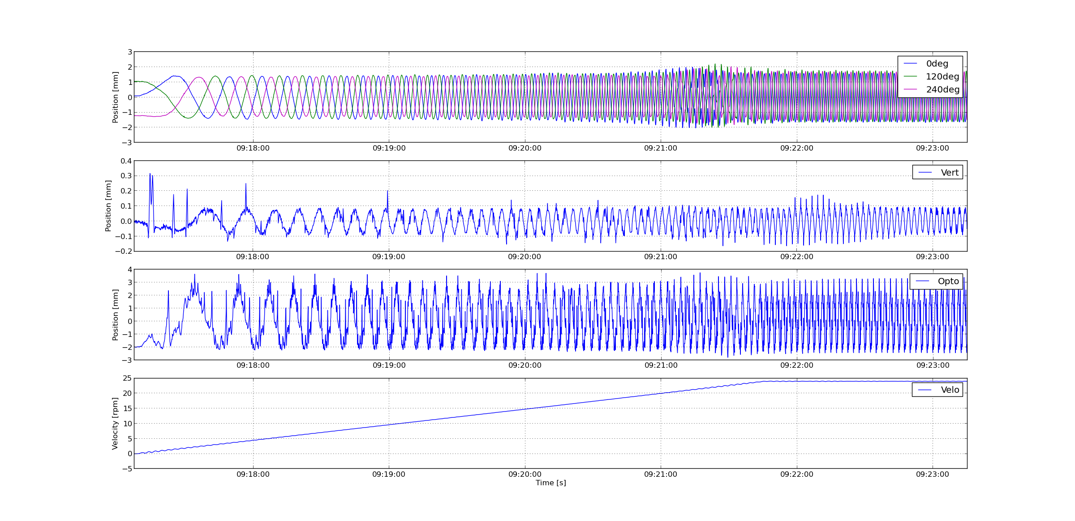

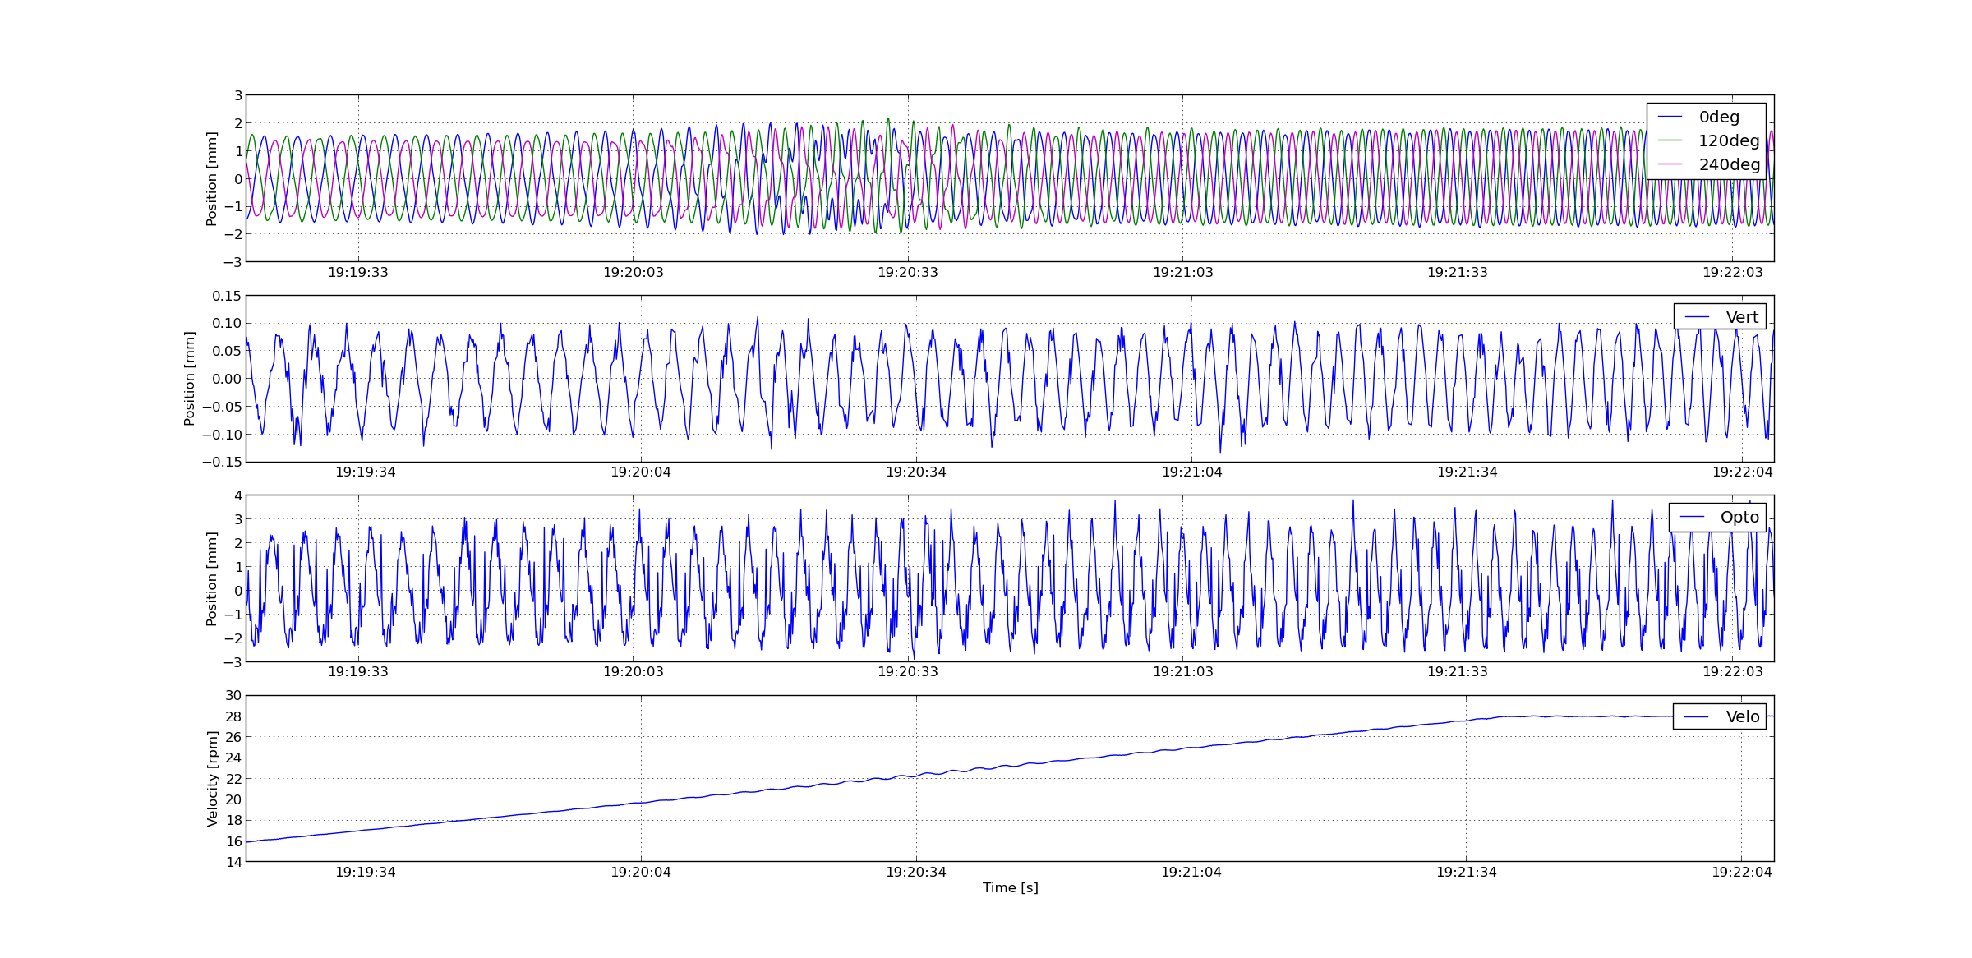

## Constant Velocity

The 5 positional sensors where used to measure rotor displacement. Figure 15 shows a few minutes of data recorded at a constant velocity of 23rpm. All sensors register a cyclic position distribution in the frequency of the target wheel rotation. In the graph for the vertical sensor values some outliers can be seen, these are generated by a whole of size M24 passing then sensor, therefore these outliers are not relevant and should be ignored. The optical sensor also shows high and low peak values for each revolution which is believed to be generated by a passing vertical weld, hence these values are relevant in the analysis.

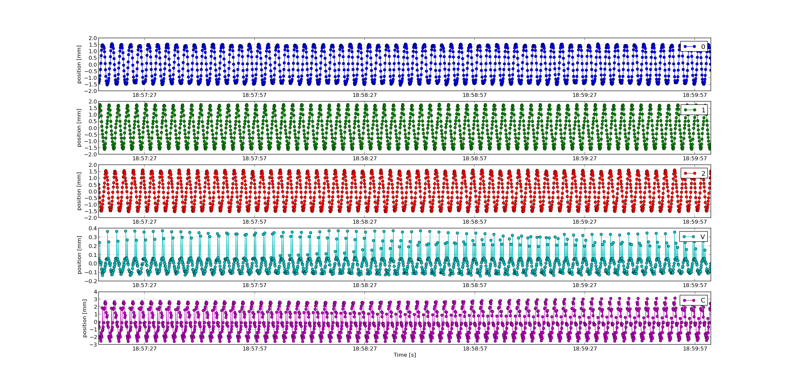

240°

Optic

Vert

120°

0°

Figure 24: Rotor positions measured with the 5 position sensors

From Figure 11 the range of displacements can be determined to be within:

* +-2 mm for horizontal position deviation
* +- 0,15 mm for vertical position deviation
* +-3 mm for horizontal deviation at the wheel circumference.

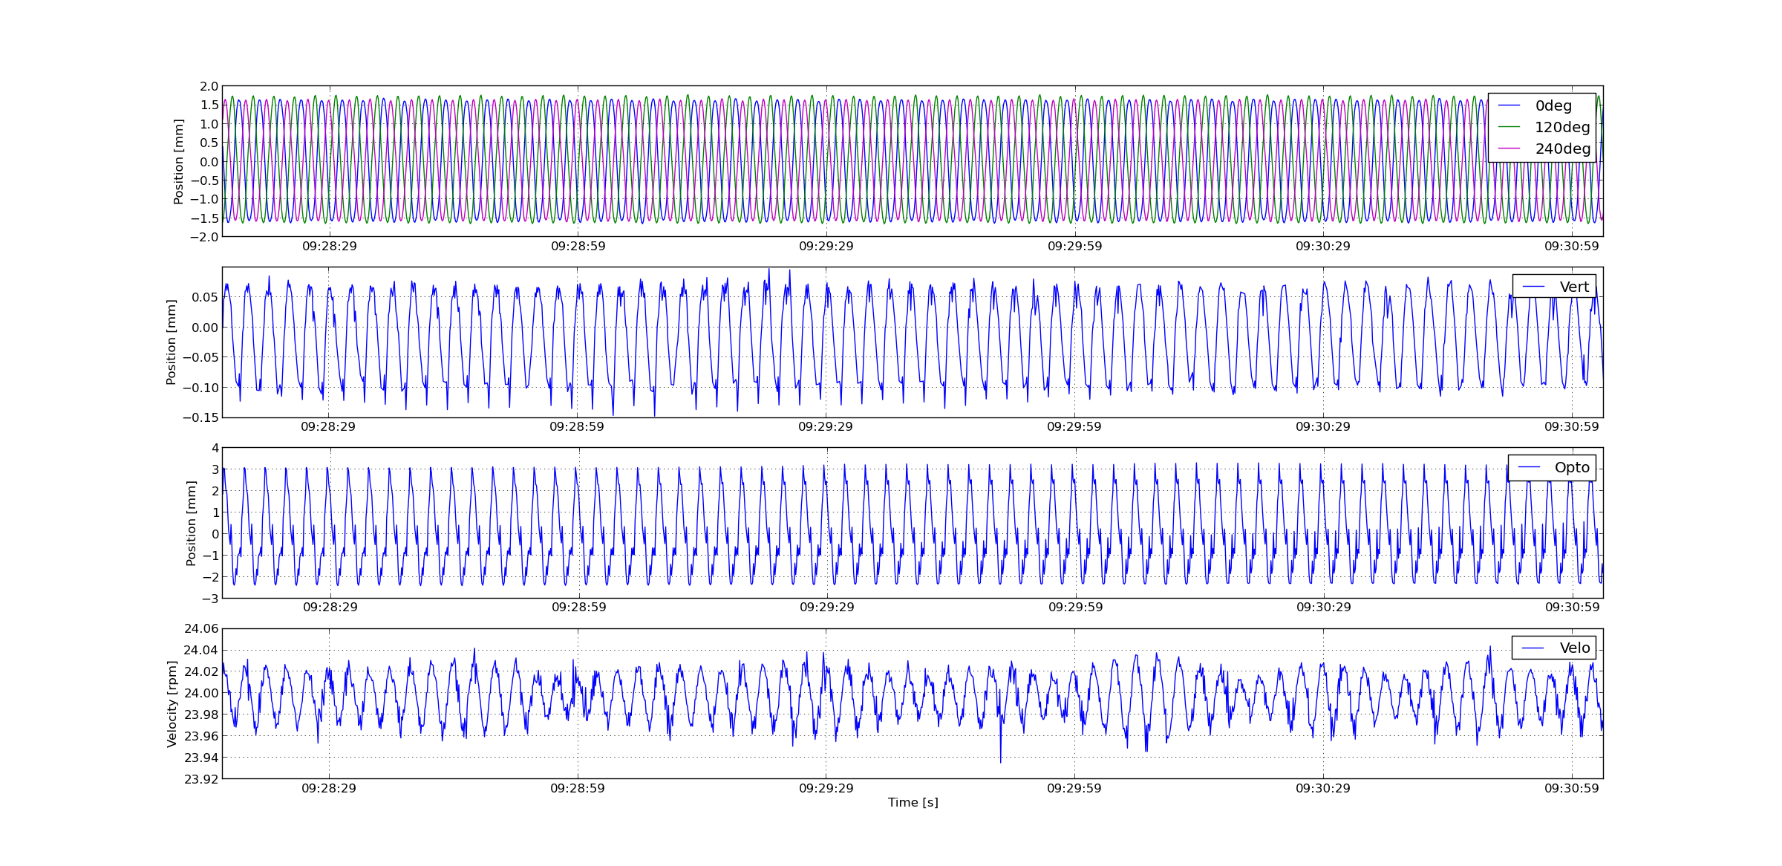

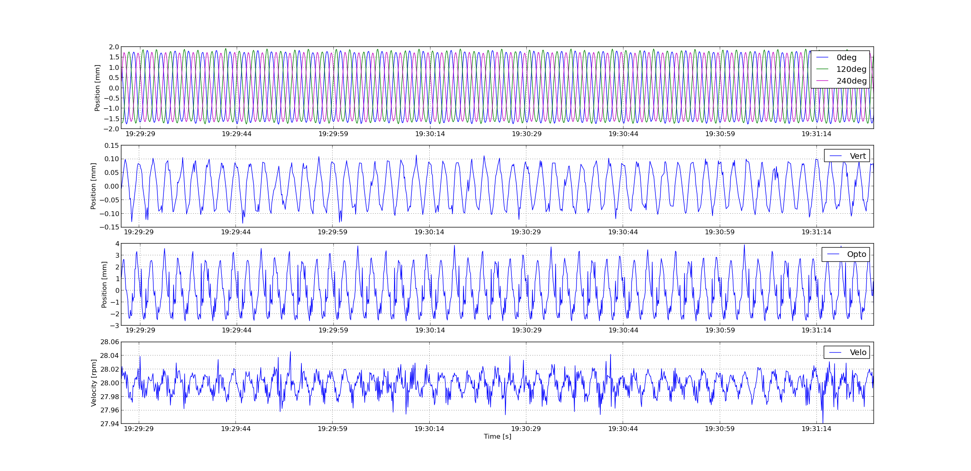

## Velocity ramp-down

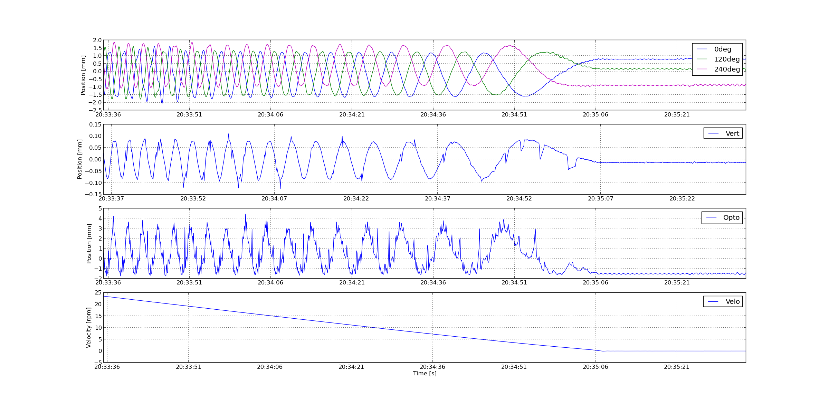

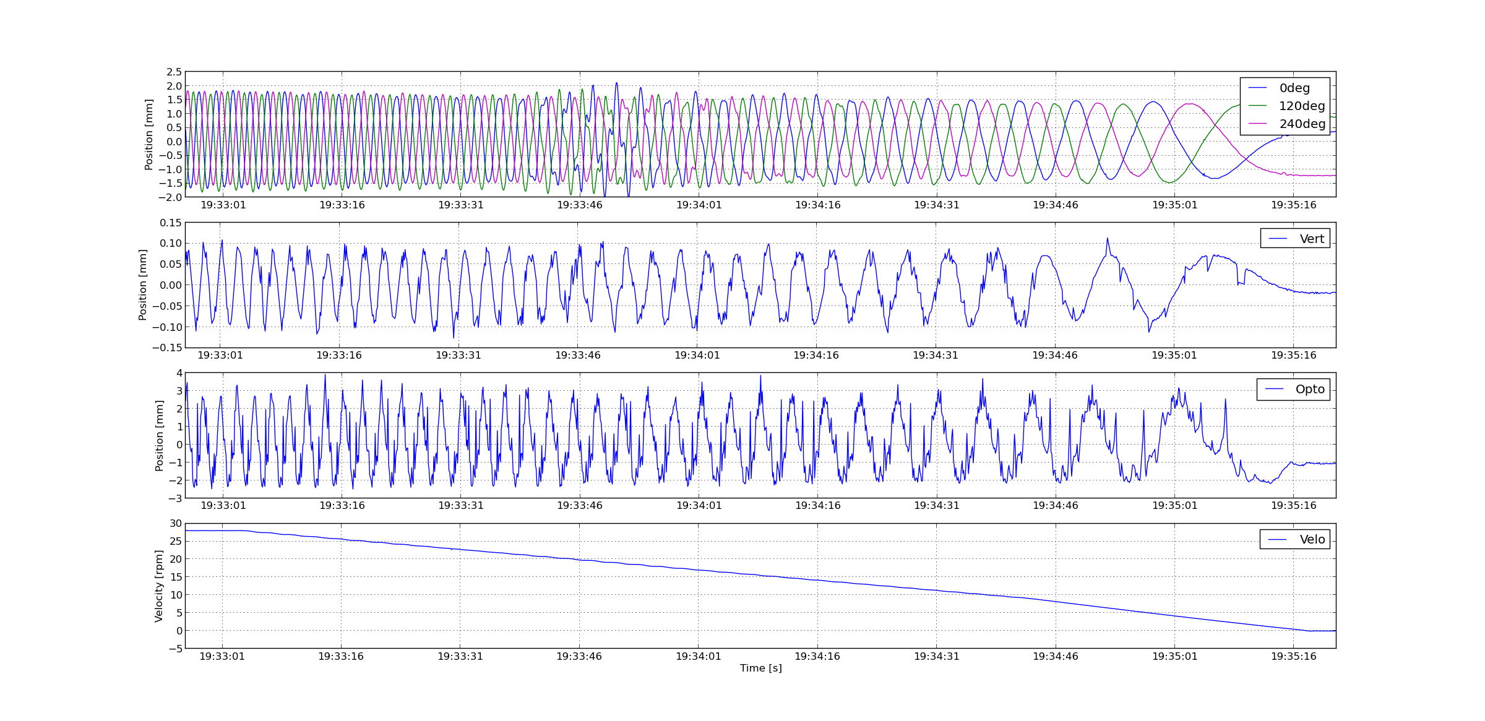

# Analysis: Rotation 10h test

This chapter analyses data acquired during the 10h test. No detailed analysis is made on this huge data set. Instead this analysis focuses on finding maximum and minimum displacements, trends and events that have occurred during the test. Chapter 5 and 6 presents a more detailed analysis on rotor velocities and displacements.

## Torque, temperature and velocity

Torque and temperature data were manually recorded approx. each 10minutes during the entire test [7]. Figure 6 show torque and temperature in rotational motor and bearings. The torque was oscillating between max and min curve approximately +-20Nm in the rotational frequency which also can be seen in Figure 10.

A step in torque can be seen just before 14:00 where the torque approximately increase 40Nm in average. At the same time the temperature also seems to increase at a higher rate.

Just before 16:00 the torque returns to the same levels as before the increase.

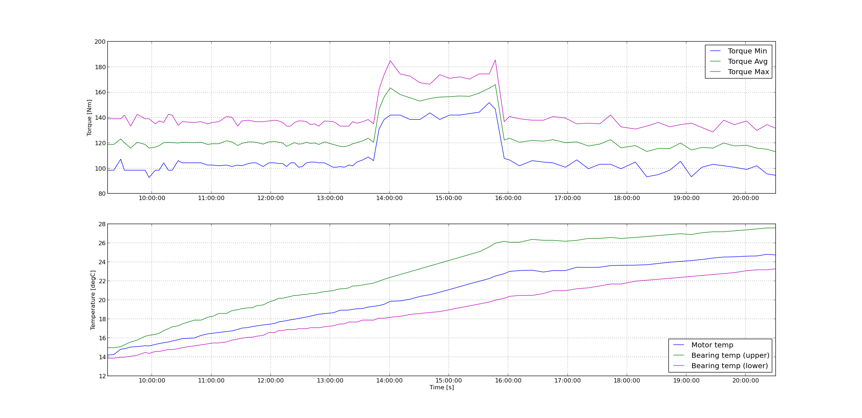

Figure 25: Upper: Manual recorded rotation drive torque [7]. Lower: Temperatures for motor and bearings.

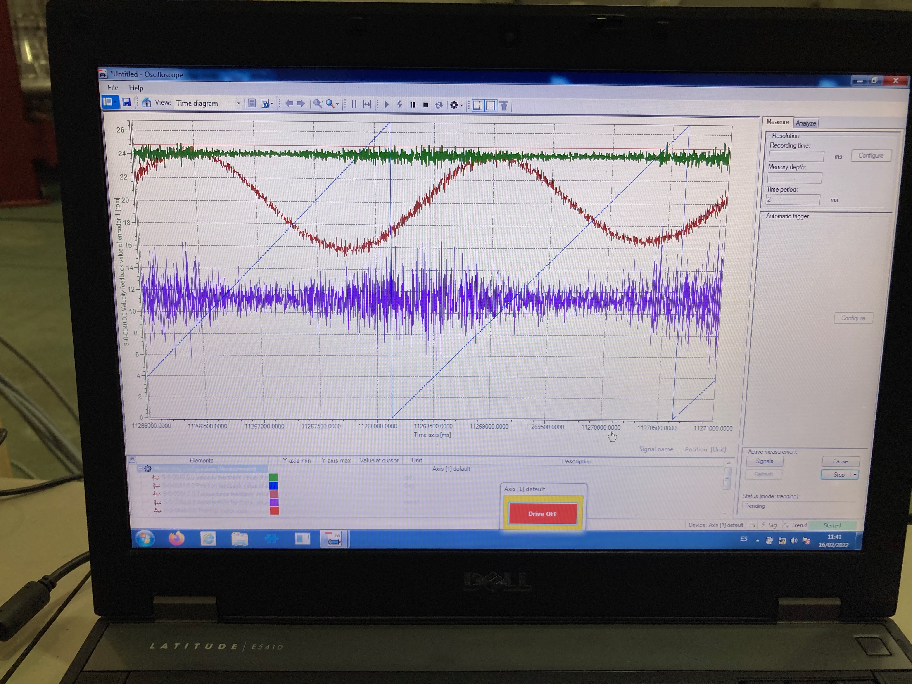

Red: Torque [% of 580Nm]

Green: Velocity [rpm]

Blue saw tooth: Position [deg]

Figure 26: Data from drive control software showing torque and velocity for two rotations (approx. 5seconds)

Figure 27 shows torque in the upper graph and rotational velocity in the lower graph. An unintended stop occurred at 16:10, the wheel was restarted directly. Velocity data was lost between 15:30 and 16:30. No direct correlation can be seen between the torque increase and the velocity signal.

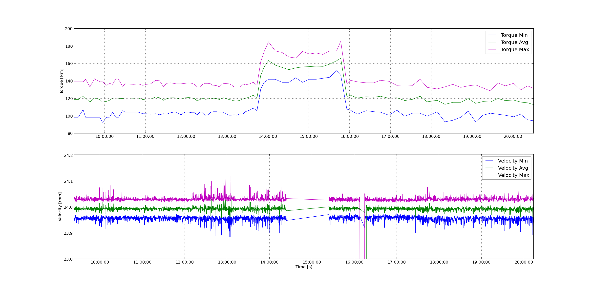

Figure 27: Upper: Manual recorded rotation drive torque [7]. Lower: max and min rotational velocities for 10s periods

The reason for this torque increase is not known but the following was discussed:

* Preloading of bearings in combination with heating resulting in increased traction
* Electrical noise on encoder signal resulting in more active control

However, none of these explanations seems feasible.

From Figure 27 it also can be concluded that the maximum variation in velocities over the entire day is happening just after 13:00 and can be quantified to +-0.13rpm.

### Rotor displacement over 10h (horizontal pedestal sensors)

Position displacements data was recorded during a 10h long period while maintain a constant velocity of the wheel at 23rpms. The data was reduced by identifying the maximum and minimum position value for each 10s period. Figure 11 show position displacement data recorded by the sensors mounted horizontally in the pedestal (not optical sensor). Unfortunately, approx. 1h of data was lost in the timespan 14:30 to 15:30.



5

4

3

8

7

6

2

1

Figure 28: Position measurements for horizontal sensors at 0º, 120º and 240º degrees over a 10h period. Upper graph shows maximum position values and lower graph shows minimum position values. Each value is a maximum or minimum of a 10 second period.

In Figure 13, a few things can be identified (see arrows in the figure):

1. Startup ramp
2. Disturbance in position of all channels (short time)
3. Minor step change in sensor 0º and spikes in values for 0º, 120º and 240º
4. Data loss
5. Minor step change in all sensors
6. Unintentional non-planned stop and start of wheel
7. Disturbance in position (long time)
8. Trends over time
9. **Velocity ramps:**

The position disturbance is highest during ramping of velocity.

1. **Disturbance in position (short time):**

A sudden disturbance happened just before 12:00. The reason for this is not known. Could be someone climbing the structure to reach the drive unit resulting in a disturbance.

1. **Small step change in sensor 0º and spikes in values for 120º and 240º:**

Just before 14:00 a change in the movement of the wheel can be identified. The values from sensor 0º sensor shifts and noise level increase slightly. This coincides with the time of a torque increase, Figure 6. Note that there can be a few minutes shift in the data since the timestamp is from two different stand-alone computers without access to network. The reason for this increase in torque is not known.

A few minutes later a spike occurs in all three sensors.

1. **Data loss:**

No data during this period.

1. **Minor step change in all sensors:**

A minor change in position for all sensors can be seen. This coincides with torque going back to original level again, Figure 6.

1. **Unintentional non-planned stop and re-start of wheel:**

An unintentional stop occurred. The wheel was re-started again.

During the velocity ramps, large deviations in the position sensors can be seen. After restart the wheel seems to stabilize in a slightly different location than before the stop.

1. **Disturbance in position (long time):**

A significant disturbance in rotor position can be identified. The rotor position moves closer to the 120-degree sensor. The disturbance lasts for approx. 15 minutes and the rotor position returns to more or less the same position as before the disturbance.

1. **Trends over time**

The rotor moves slightly towards the 120-degree sensor during the test and might take even longer than 10h to stabilize.

Table 1: Statistics for horizontal pedestal sensors over a 10h period.

|  |  |  |  |  |  |  |
| --- | --- | --- | --- | --- | --- | --- |
|  | **0º**  **max** | **0º**  **min** | **120º**  **max** | **120º**  **min** | **240º**  **max** | **240º**  **min** |
| **Values []** | 3569 | 3569 | 3572 | 3572 | 3572 | 3572 |
| **Max [mm]** | **2.01** | 1.27 | **2.16** | 0.52 | **1.97** | -0.25 |
| **Min [mm]** | 0.73 | -2.01 | -0.98 | -2.05 | -1.25 | -1.86 |
| **Std [mm]** | 0.06 | 0.10 | 0.08 | 0.07 | 0.11 | 0.04 |
| **Max Range [mm]** | +-2.01 | | **+-2.16** | | +-1.97 | |

Table 1 summarizes some statistics from the data in Figure 11. The total position displacement range over 10h can be calculated to **+-2.16** mm for the pedestal sensors**.**

**Note: The raw data was sampled at 10Hz resulting in that the actual movement can be slightly larger.**

### Rotor circumference displacement over 10h (horizontal optical sensor)

The data collected from the optical sensor, mounted to measure on the circumference of the wheel is presented in Figure 13.The data show slow oscillations with a frequency at approx. four oscillations per hour. This could be related to aliasing generated by sampling rate.

A slow trend that the wheel is moving closer to the sensor over time can be observed.

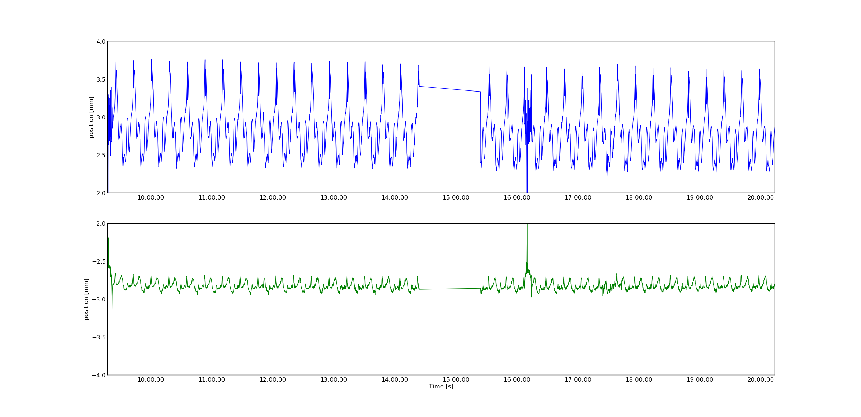

Figure 29: Position measurements for the optical sensor measuring circumference deviation over a 10h period. Upper graph shows maximum position values and lower graph shows minimum position values. Each value is a maximum or minimum of a 10 second period.

Table 2 shows a summary of the data plotted in Figure 10. The maximum recorded move during the 10h period was +-3.76 mm.

Table 2: Statistics for horizontal optical sensor measuring circumference position deviation over a 10h period

|  |  |  |
| --- | --- | --- |
|  | **Opto**  **max** | **Opto**  **min** |
| **Values []** | 3573 | 3573 |
| **Max [mm]** | **3.76** | 0.16 |
| **Min [mm]** | -1.32 | -3.15 |
| **Std [mm]** | 0.35 | 0.08 |
| **Max Range [mm]** | **+-3.76** | |

### Rotor vertical displacement over 10h

The data collected from the vertical pedestal sensor, measuring vertical movement of the wheel is presented in Figure 11. The highest variations can be found during start and stop ramps.

A slow trend that the wheel is moving closer or to the pedestal over time can be observed. This is most likely because of elongation of the shaft due to heat up.

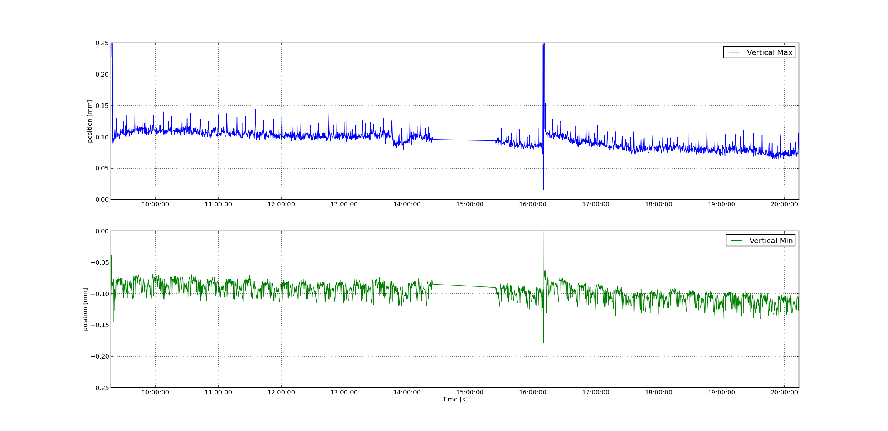

Figure 30: Position measurements for the vertical pedestal sensor over a 10h period. Upper graph shows maximum position values and lower graph shows minimum position values. Each value is a maximum or minimum of a 10 second period.

Table 3 shows a summary of the data plotted in Figure 11. The maximum recorded move during the 10h period was +-0.43mm.

Table 3: Statistics for vertical pedestal sensor measuring vertical position deviation over a 10h period

|  |  |  |
| --- | --- | --- |
|  | **Vert**  **max** | **Vert**  **min** |
| **Values []** | 2358 | 2358 |
| **Max [mm]** | **0.43** | 0.05 |
| **Min [mm]** | 0.02 | -0.18 |
| **Std [mm]** | 0.02 | 0.01 |
| **Max Range [mm]** | **+-0.43** | |

# Conclusions

Sample faster next time (100hz)

Rotor displacements:

Horizontal Circumference: +-3.76mm

Horizontal pedestal: +-2.16mm

Vertical pedestal: +-0.46mm

Long test series needed for heat up and finding maximum values

Most things happen during ramps

Worst case for velocity and displacements was found during the 10h test.

+-0.13rpm

# references

1. EtherCAT organization, <https://www.ethercat.org>
2. ecmc, open source motion control, <https://accelconf.web.cern.ch/icalepcs2017/talks/mocpl05_talk.pdf>
3. Control system configurations, <https://github.com/anderssandstrom/ecmc_target_muts_logger>
4. Micro-Epsilon laser triangulation sensor, <https://www.micro-epsilon.com/displacement-position-sensors/laser-sensor/optoNCDT_2300_basic/>
5. Telemess eddy current sensors, <https://www.telemess.de>
6. Telemess eddy current sensor calibration tables, <https://github.com/anderssandstrom/ecmc_target_muts_logger/blob/master/src/bptTypeTelemessCalib.dbd>
7. Manual torque and temperature measurements by AVS, <https://gitlab.esss.lu.se/mcag/target/target_fat_galicia_analysis/-/blob/master/doc/N046_TorqueDataRecord_16_02_2022_final.xlsm>
8. Bosch Rexroth, <https://boschrexroth.com>

Document Revision history

| Revision | Reason for and description of change | Author | Date |
| --- | --- | --- | --- |
| 1 | First issue | Anders Sandström | 2022-03-01 |
|  |  |  |  |
|  |  |  |  |

# Appendix A Micro Epsilon ILD2300 Calibration REPORT



# Appendix B: Telemess A30-S01



# Appendix C: Telemess A42

